UNITED STATES
SECURITIES AND EXCHANGE COMMISSION
Washington, D.C. 20549

FORM 8-K

CURRENT REPORT
PURSUANT TO SECTION 13 OR 15(d) OF THE
SECURITIES EXCHANGE ACT OF 1934

Date of Report (Date of earliest event reported): May 14, 2026

Faraday Future Intelligent Electric Inc.
(Exact name of registrant as specified in its charter)

Delaware |  | 001-39395 |  | 84-4720320
(State or other jurisdiction |  | (Commission File Number) |  | (I.R.S. Employer
of incorporation) |  |  |  | Identification No.)

1990 E. Grand Avenue
El Segundo, CA |  | 90245
(Address of principal executive offices) |  | (Zip Code)

(424) 276-7616
(Registrant’s telephone number, including area code)

Not Applicable
(Former name or former address, if changed since last report)

Check the appropriate box below if the Form 8-K filing is intended to simultaneously satisfy the filing obligation of the registrant under any of the following provisions:

☐ | Written communications pursuant to Rule 425 under the Securities Act (17 CFR 230.425)

☐ | Soliciting material pursuant to Rule 14a-12 under the Exchange Act (17 CFR 240.14a-12)

☐ | Pre-commencement communications pursuant to Rule 14d-2(b) under the Exchange Act (17 CFR 240.14d-2(b))

☐ | Pre-commencement communications pursuant to Rule 13e-4(c) under the Exchange Act (17 CFR 240.13e-4(c))

Securities registered pursuant to Section 12(b) of the Act:

Title of each class |  | Trading Symbol(s) |  | Name of each exchange on which registered
Class A common stock, par value $0.0001 per share |  | FFAI |  | The Nasdaq Stock Market LLC
Redeemable warrants, exercisable for shares of Class A common stock at an exercise price of $110,400.00 per share |  | FFAIW |  | The Nasdaq Stock Market LLC

Indicate by check mark whether the registrant is an emerging growth company as defined in Rule 405 of the Securities Act of 1933 (§230.405 of this chapter) or Rule 12b-2 of the Securities Exchange Act of 1934 (§240.12b-2 of this chapter).

Emerging growth company ☐

If an emerging growth company, indicate by check mark if the registrant has elected not to use the extended transition period for complying with any new or revised financial accounting standards provided pursuant to Section 13(a) of the Exchange Act. ☐

Item 2.02 Results of Operations and Financial Condition.

On May 14, 2026, Faraday Future Intelligent Electric Inc. (the “Company”) issued a press release in which the Company provided certain first quarter 2026 financial results, as well as its 2026 outlook. The full text of the press release is furnished herewith as Exhibit 99.1 to this Current Report on Form 8-K and is incorporated herein by reference.

Item 8.01 Other Events.

In connection with a conference call held by the Company on May 14, 2026, to discuss certain first quarter 2026 financial results, as well as its 2026 outlook, the Company referenced the presentation furnished as Exhibit 99.2 to this Current Report on Form 8-K and incorporated herein by reference.

The information contained in Items 2.02 and 8.01 in this Current Report on Form 8-K and the information in Exhibits 99.1 and 99.2 hereto is being furnished and shall not be deemed “filed” for purposes of Section 18 of the Securities Exchange Act of 1934, as amended (the “Exchange Act”), or otherwise subject to the liabilities of that section, nor shall it be deemed incorporated by reference in any filing under the Securities Act of 1933, as amended, or the Exchange Act, except as expressly set forth by specific reference in such a filing.

Item 9.01 Financial Statements and Exhibits.

(d) Exhibits. The following exhibits are filed with this Current Report on Form 8-K:

No. |  | Description of Exhibits
99.1 |  | Press Release dated May 14, 2026
99.2 |  | Investor Presentation (First Quarter 2026 Earnings Release) dated May 14, 2026
104 |  | Cover Page Interactive Data File (embedded within the Inline XBRL document)

1

SIGNATURE

Pursuant to the requirements of the Securities Exchange Act of 1934, the registrant has duly caused this report to be signed on its behalf by the undersigned hereunto duly authorized.

 | FARADAY FUTURE INTELLIGENT ELECTRIC INC.
Date: May 14, 2026 | By: | /s/ Koti Meka
 | Name: | Koti Meka
 | Title: | Chief Financial Officer

2
Exhibit 99.1

Faraday Future Announces Q1 2026 Financial Results: Upgrades to a Physical AI Company, with EAI Robots Achieving Ecosystem Revenue and Positive Gross Margin, Raises 2026 Robot Shipment Target to 1,500 Units and Plans Early-June Launch of New Robot

 | ● | EAI robotics emerges as the Company’s new revenue engine in its inaugural quarter of deliveries. A total of $512,000 revenue in Q1 2026 nearly matches full-year 2025 revenue of $536K. Software skill package revenue accounting for 26%, operating loss narrowing 18% Year-Over-Year, and stockholders’ equity keep positive and grew 148% compared with Q4 2025.

 | ● | Evolving into a Physical AI company with the “AI First” philosophy, FF is focusing on two product engines: Embodied AI (EAI) humanoid and bionic robots, and EAI automotive robots. By building a “Three-in-One ecosystem” of “Device, Data, and Brain & Open-Source and Open Developer Platform,” the Company aims to create an evolutionary flywheel, with the goal of maximizing commercial value.

 | ● | EAI robotics shipments reached 68 units by end of April, exceeding expectations; Driven by rising demand across the FF’s four primary product lines and key application scenarios, including education, security inspection, reception and guided tours, performance, and university research, as well as the upcoming new products, the Company raised the full-year shipment target to 1,500 units, supported by a major new product launch in early June, aiming to build the first large-scale EAI robotics education system in the U.S. and serving as the primary catalyst for the inaugural year of the nation’s EAI robotics education ecosystem. The Company believes education is expected to become the largest initial application scenario in the consumer-facing robotics market.

 | ● | Secured $45 million in new financing to support the first phase of robotics success while optimizing its capital structure to advance long-term strategic financing initiatives; the Company continues to optimize its capital structure and is currently actively engaging with strategic investors and long-term capital to secure the remaining funding required for the mass production of the FX Super One.

 | ● | Upgraded internal governance to an “AI-PPTI” framework, completely reconstructing company operations with AI agents and data-driven decision making.

 | ● | Following the conclusion of the SEC investigation with no penalties and the full return of the founding team, FF is upgrading its previous “Ten-Punch Combo” strategy into “Five Key Transformations” under AI-First philosophy. The full strategic plan set to be unveiled in YT’s Investor Weekly Report this coming Sunday.

Los Angeles, CA (May 14, 2026) -- Faraday Future Intelligent Electric Inc. (Nasdaq: FFAI) (“FF”, “Faraday Future”, or the “Company”), a California-based global Embodied AI (EAI) ecosystem company, today announced financial results for its first quarter ended March 31, 2026, and provided updates on key operational and strategic developments.

“The first quarter of 2026 marked a pivotal transition for our business as our Three-in-One EAI ecosystem strategy began forming a tangible commercial closed loop,” said YT Jia, Global CEO of Faraday Future. “We have officially upgraded our positioning to become a physical AI ecosystem company. By achieving scaled delivery of humanoid and bionic EAI robot terminals, generating positive single-product gross margins, we are rapidly converting our first-mover advantage into sustained competitive leadership.”

Jia added: “Looking ahead, we will fully implement the Strategy and our industrial bridge strategy. Our priorities are building a robotics ecosystem-driven revenue base, focusing on humanoid and bionic robots, with automotive robots serving as a complementary focus, and achieving a clear path toward sustainable profitability. We will also continue advancing our long-term ecosystem of ‘Device, Data, and Brain & Open-Source and Open Developer Platform.’ With the full return of the founding team, launching and executing our upgraded set of transformation initiatives, we are positioned to drive long-term value creation, rebuild capital market trust and confidence, and enter the firm’s next phase of growth.”

FIRST QUARTER 2026 HIGHLIGHTS

Robotics Delivering Early Validation as a High-Margin, Capital-Efficient Growth Engine

The Company’s EAI Robotics business reached a key inflection point in the first quarter of 2026, generating initial sales revenue and positive product gross margin while establishing a foundation for scaled deployment. As of April 30, 2026, FF had shipped 68 EAI robots, and May shipments are expected to continue accelerating as the Company progresses toward its first shipment quarter target of 200 units. The Company expects cumulative shipments to exceed 1,500 EAI robots in 2026.

This momentum is being supported by continued expansion of the Company’s EAI Robotics strategy, including education-focused use cases, broader ecosystem development and more than 1,200 non-binding, paid pre-orders at launch. FF believes EAI Robotics provides a capital-efficient pathway to support near-term commercialization, cash flow generation and long-term EAI ecosystem expansion.

On the compliance front, following the earlier certifications of the Futurist and Master humanoid robots, the FX Aegis quadruped completed its full compliance certification in the United States. As a result, all FX Aegis robots delivered to date can now be converted to formal deliveries, supporting the Company’s continued expansion in the U.S. EAI Robotics market.

Unified EAI Strategy Driving Ecosystem Value

The Company continued to advance its Three-in-One EAI ecosystem strategy, integrating EAI devices with the EAI Brain, Open Source and Open Developer Platform capabilities, and the EAI Data Factory. During the quarter and subsequent period, FF launched its developer portal, advanced Open Claw as a key component of its open developer platform and began applying these capabilities across FF EAI robots.

The Data Factory Business Unit signed its first sales order in early May. The Data Factory continues to build capabilities for efficient, large-scale data collection, and structured processing, transforming low-cost raw data from real-world deployments into high-quality training data through advanced post-processing.

Strengthened Governance and System Building

To drive the “AI First” philosophy, the Company completely upgraded its internal AI governance from “PPTIA” to “AI-PPTI.” This framework transitions AI from an auxiliary tool to key infrastructure, reconstructing organizational processes to use AI agents for data-driven operations and decision making.

Organizationally, the Company continued to strengthen its leadership structure, operating infrastructure, and EAI education ecosystem. The Board has acknowledged and appointed FF Founder YT Jia as Global CEO and Jerry Wang as Global Executive Chairman. The Board has also accepted Matthias Aydt’s resignation as Global Co-CEO and appointed independent director Chad Chen as Lead Independent Director.

This leadership transition represents a significant organizational and governance change for the Company marking the full return of the founding team and founder-driven entrepreneurial spirit at both the Board and core management levels, and represents a key step in deepening the execution of the Company’s EAI strategy, creating long-term value for stockholders, and further reinforcing the Company’s guiding principle of putting stockholders first.

To support its next stage of growth, the Company relocated its headquarters to El Segundo, CA, also known as Silicon Beach, enhancing access to senior talent and reinforcing its position within a leading technology and innovation hub. FF also established a dedicated Education Ecosystem Product Line to support the development and scaled deployment of its EAI robotics education system. In April, California State Treasurer Fiona Ma joined the unveiling of the FF EAI Robotics Education & Innovation Lab, supporting the Company’s broader efforts to expand EAI education use cases and engage with government, education and industry partners.

2

Regulatory Clarity Achieved and Capital Structure Strengthened

On March 18th, the SEC officially concluded its investigation of over four years without taking any penalties or legal action against the Company or its leadership, removing a major historical overhang.

The Company leveraged this momentum to improve its capital position. The Company successfully secured $45 million in new financing from American institutional investors. Additionally, FF revised an agreement with an AIXC-designated third party to secure a $12 million subscription, replacing anti-dilution clauses with fixed obligations linked to operation milestones. Looking forward, FF remains fully committed to taking all necessary measures to satisfy Nasdaq’s minimum bid price compliance requirement during its 180-day grace period.

RESULTS FOR FIRST QUARTER 2026

 | ● | Revenue: For the first quarter of 2026, robotics emerged as the Company’s new revenue engine in its inaugural quarter of deliveries. The company generated revenue of $512,000, representing a 62% increase from $316,000 in the same period last year, which itself nearly matches full-year 2025 revenue of $536K. This includes both device sales and ecosystem revenue, with ecosystem revenue (including SKILLS, software capability packs, etc.) accounting for 26% of total revenue.

 | ● | Total Stockholders’ Equity: Increased 148% to $19.2 million from the prior-year end, making the second consecutive quarter of positive equity growth

 | ● | Net Loss from Operations: $35.9 million, a 18% decrease from $43.8 million in Q1 2025.

 | ● | G&A Expenses: Declined 33% year-over-year, from $13.7 million in Q1 2025 to $9.2 million in Q1 2026, primarily driven by a substantial reduction in professional fees, reflecting the Company’s continued discipline in optimizing its cost structure.

 | ● | Operating Cash Outflow: Increased by 55% to $31.5 million, compared to $20.3 million in Q1 2025, primarily driven by losses from continuing operations and changes in working capital.

 | ● | Total Operating Expenses: $24.5 million, representing an increase of $1.8 million compared to Q1 2025.

2026 OUTLOOK

Looking ahead, 2026 is expected to mark an important transition year for Faraday Future as the Company advances from initial EAI Robotics commercialization toward broader scaling of its Three-in-One EAI ecosystem strategy. The Company’s priorities are focused on increasing EAI robot deliveries, expanding education-driven use cases, improving operating cash flow and further validating the integrated Device-Data-Brain model across EAI Robotics and EAI Vehicles.

EAI Robotics: Scaling a Capital-Efficient Commercial Platform

The Company expects EAI Robotics to be its primary near-term commercialization priority in 2026. FF is targeting cumulative shipments of more than 1,500 EAI robots by year-end, with education expected to serve as the initial entry point for scaled deployment. Over time, the Company plans to expand into universities, research institutions, vocational education systems and additional high-value use cases, including security, inspection and other enterprise applications.

From a product perspective, FF expects to initially prioritize humanoid robotics while progressively expanding into quadruped robotics and other intelligent form factors. This phased approach is intended to support real-world validation, refine products within defined use cases, establish repeatable deployment models, and develop standardized solutions that can scale over time.

Building on positive product gross margin achieved in early deliveries, the Company intends to continue improving product economics through increased scale, supply chain efficiency, and ongoing product iteration. Given the lower capital requirements of robotics relative to the automotive business, FF believes EAI Robotics can support near-term revenue generation, operating cash flow improvement, and broader EAI ecosystem development.

3

Three-in-One EAI Ecosystem: Connecting Devices, Brain and Data

The Company’s EAI Robotics strategy is expected to further validate its Three-in-One EAI ecosystem, which integrates EAI Devices, the EAI Brain and Open Platform, and the EAI Data Factory. As more EAI robots are deployed across education and enterprise environments, FF expects to generate real-world data that can support model training, product optimization and continuous improvement in user experience.

This feedback loop is central to the Company’s Device-Data-Brain architecture. Increased device deployment is expected to generate data, data improves the AI system, improved AI capabilities enhance product utility and stronger product performance supports further adoption. Over time, FF believes this closed-loop model can support broader commercialization opportunities beyond hardware sales, including software, data applications and ecosystem partnerships.

The Company believes education is expected to become the largest initial application scenario in the consumer-facing robotics market. Strategic collaboration with educational institutions, research organizations and vocational education partners is expected to play an important role in this ecosystem. These partnerships are intended to support talent development, technology innovation, application deployment and the development of a broader EAI robotics education market.

EAI Automotive Robots: Advancing FX Super One with Capital Discipline

In automotive robots (EAI Vehicles), the Company will continue advancing FX Super One while maintaining a disciplined approach to capital deployment and production ramp up. Based on strategic cooperation with its bridge strategy partner, FF plans to upgrade FX Super One to a more competitive 800V architecture or accelerate the AIHER project, while pausing the original Super One 400V cooperation project.

This approach is intended to improve product competitiveness, reduce near-term cash outflows and better align vehicle execution with capital availability, operational readiness and long-term stockholder value creation. The Company expects EAI Vehicles to remain an important component of its broader EAI strategy, while EAI Robotics provides a more capital-efficient pathway for near-term commercialization and ecosystem validation.

Capital Strategy: Restoring Market Confidence and Improving Financing Efficiency

From an operating and financial perspective, the Company is focused on strengthening revenue recognition, budgeting, cost management and monthly operating review processes to support robotics-driven revenue realization, improve margin visibility and enhance cash flow discipline.

From a capital perspective, FF is shifting toward a longer-term, value-oriented capital structure. The Company intends to strengthen investor communication, reduce reliance on high-cost short-term financing channels and continue engaging strategic and institutional investors with the objective of improving financing efficiency, dilution efficiency and financial flexibility over time.

Long-Term Positioning

FF is officially evolving into a U.S.-based Physical AI company, focusing on two product engines: Embodied AI (EAI) humanoid and bionic robots, and EAI automotive robots. By building a “Three-in-One ecosystem” of “Device, Data, and Brain & Open-Source and Open Platform,” the Company aims to create an evolutionary flywheel of “scaled device delivery, data collection and training, continuous evolution of the EAI Brain, stronger product capability, and larger-scale delivery”, with the goal of maximizing commercial value.

EARNINGS WEBCAST

Faraday Future management will host a webcast today, May 14, 2026, at 7:30 p.m. Eastern time (4:30 p.m. Pacific time). Interested investors and other parties can listen to a webcast of the conference call by logging onto the Investor Relations section of the Company’s website at https://investors.ff.com/. A replay of the webcast will be available on the Company’s website shortly thereafter. More detail on FF’s 2026 Q1 earnings, when filed, can be found in our SEC filings and online at https://investors.ff.com/financial-information/sec-filings.

4

ABOUT FARADAY FUTURE

Founded in 2014, Faraday Future (FF) is a U.S.-based Physical AI ecosystem company dedicated to reshaping the future of robotics and mobility solutions through AI innovation and technologies. FF focuses on two major product strategies within the Embodied AI (EAI) robotics business: EAI humanoid and bionic robots, and EAI automotive-focused robots. By building a Three-in-One ecosystem of “Device, Data, EAI Brain & Open-Source and Open Platform,” FF aims to create an evolutionary flywheel: scaled device delivery, data collection and training, continuous evolution of the EAI Brain, stronger product capability, and even larger-scale delivery and deployment. Through this flywheel, FF seeks to maximize its commercial value and lead to the advancement of Physical AI. For more information, please visit Faraday Future’s official website: https://www.ff.com/

FORWARD LOOKING STATEMENTS

This press release includes “forward looking statements” within the meaning of the safe harbor provisions of the United States Private Securities Litigation Reform Act of 1995. When used in this press release, the words “plan to,” “can,” “will,” “should,” “future,” “potential,” and variations of these words or similar expressions (or the negative versions of such words or expressions) are intended to identify forward-looking statements. These forward-looking statements, which include statements regarding FF’s entry into the embodied AI robotics market, involve a number of known and unknown risks, uncertainties, assumptions and other important factors, many of which are outside the Company’s control, which could cause actual results or outcomes to differ materially from those discussed in the forward-looking statements.

Important factors, among others, that may affect actual results or outcomes include, among others: the Company’s ability to maintain its listing on Nasdaq; the availability of sufficient share capital to execute on its strategy, which the Company currently lacks; the agreement of stockholders to substantially increase the Company’s share capital, which could result in substantial additional dilution; the Company’s ability to homologate FX vehicles for sale; the Company’s ability to secure the necessary funding to execute on the FX strategy, which will be substantial; demand for the Super One; demand for the Company’s robotics products; competition in the robotics industry, which includes companies with far superior experience, funding and name recognition; the Company’s reliance on a single OEM for most of its robotics products; the Company’s ability to get the planned robotics products to comply with all applicable U.S. rules and regulations; the ability of the robotics OEM to timely supply robotics to the Company; tariff uncertainty for imported products, particularly from China; the ability of the U.S. Department of Commerce to review, condition, or prohibit robotics-related transactions with a China OEM; demand from automobile dealers for robotics products; the Company’s ability to maintain its listing on Nasdaq; the Company’s ability to timely regain compliance with Nasdaq’s $1.00 minimum bid price requirement; that the Company’s common stock will be suspended from trading on Nasdaq if the closing price of its Class A common stock is $0.10 or less for 10 consecutive trading days; the availability of sufficient share capital to execute on its strategy, which the Company currently lacks; the agreement of stockholders to substantially increase the Company’s share capital, which could result in substantial additional dilution; the ability to secure the necessary agreements to upgrade the Super One to an 800V architecture or to develop the AIHER model, none of which have been finalized; the Company’s ability to design and develop AIHER technology; the Company’s ability to secure financing for the 800V architecture of the Super One; the Company’s ability to secure an occupancy certificate for its Hanford facility; the Company’s ability to continue as a going concern and improve its liquidity and financial position; the Company’s ability to pay its outstanding obligations; the Company’s ability to remediate its material weaknesses in internal control over financial reporting and the risks related to the restatement of previously issued consolidated financial statements; the Company’s limited operating history and the significant barriers to growth it faces; the Company’s history of losses and expectation of continued losses; the success of the Company’s payroll expense reduction plan; the Company’s ability to execute on its plans to develop and market its vehicles and robots and the timing of these development programs; the Company’s estimates of the size of the markets for its vehicles and robots and cost to bring those vehicles to market; the rate and degree of market acceptance of the Company’s vehicles; the Company’s ability to cover future warranty claims; the success of other competing manufacturers; the performance and security of the Company’s vehicles; current and potential litigation involving the Company; the Company’s ability to receive funds from, satisfy the conditions precedent of and close on the various financings described elsewhere by the Company; the result of future financing efforts, the failure of any of which could result in the Company seeking protection under the Bankruptcy Code; the Company’s indebtedness; the Company’s ability to use its “at-the-market” program; insurance coverage; general economic and market conditions impacting demand for the Company’s products; potential negative impacts of a reverse stock split; potential cost, headcount and salary reduction actions may not be sufficient or may not achieve their expected results; circumstances outside of the Company’s control, such as natural disasters, climate change, health epidemics and pandemics, terrorist attacks, and civil unrest; risks related to the Company’s operations in China; the success of the Company’s remedial measures taken in response to the Special Committee findings; the Company’s dependence on its suppliers and contract manufacturer; the Company’s ability to develop and protect its technologies; the Company’s ability to protect against cybersecurity risks; and the ability of the Company to attract and retain employees, any adverse developments in existing legal proceedings or the initiation of new legal proceedings, and volatility of the Company’s stock price. You should carefully consider the foregoing factors and the other risks and uncertainties described in the “Risk Factors” section of the Company’s Form 10-K for the year ended December 31, 2025 filed with the SEC on March 31, 2026, and other documents filed by the Company from time to time with the SEC.

CONTACTS

Investors (English): ir@ff.com
Investors (Chinese): cn-ir@faradayfuture.com
Media: john.schilling@ff.com

5

Appendix Financial Statements

Faraday Future Intelligent Electric Inc.
Unaudited Condensed Consolidated Balance Sheets
(in thousands, except share and per share data)

 |  | March 31,  2026 |  |  |  | December 31,  2025
Assets
Current assets
Cash and cash equivalents |  | $ | 12,231 |  |  | $ | 34,927
Restricted cash |  |  | 29 |  |  |  | 27
Digital assets |  |  | 6,197 |  |  |  | 10,250
Accounts receivable |  |  | 273 |  |  |  | 257
Notes receivable, net of allowance for credit losses of $4,698 and $4,555 and on March 31, 2026, and December 31, 2025, respectively |  |  | 385 |  |  |  | 343
Inventory, net (see Note 4) |  |  | 1,465 |  |  |  | 3,258
Deposits (see Note 5) |  |  | 13,758 |  |  |  | 10,499
Other current assets (see Note 5) |  |  | 7,565 |  |  |  | 8,963
Total current assets |  |  | 41,903 |  |  |  | 68,524
Property, plant and equipment, net |  |  | 146,932 |  |  |  | 155,303
Operating lease right-of-use assets, net |  |  | 14,861 |  |  |  | 4,950
Intangible assets, net |  |  | 4,647 |  |  |  | 4,639
Goodwill |  |  | 23,692 |  |  |  | 25,764
Other non-current assets (see Notes 4 and 5) |  |  | 18,106 |  |  |  | 18,682
Total assets |  | $ | 250,141 |  |  | $ | 277,862
Liabilities and stockholders’ equity
Current liabilities
Accounts payable |  | $ | 53,366 |  |  | $ | 57,277
Accrued expenses and other current liabilities (see Note 7) |  |  | 42,134 |  |  |  | 45,499
Related party accrued expenses and other current liabilities (see Note 7) |  |  | 12,988 |  |  |  | 13,179
Warrant liabilities |  |  | 960 |  |  |  | 1,950
Related party accrued interest |  |  | 14 |  |  |  | 19,933
Other financing liabilities, current portion |  |  | 1,005 |  |  |  | 951
Operating lease liabilities, current portion |  |  | 1,583 |  |  |  | 1,443
Notes payable, current portion |  |  | 4,349 |  |  |  | 4,432
Related party notes payable |  |  | 1,510 |  |  |  | 3,507
Total current liabilities |  |  | 117,909 |  |  |  | 148,171
Other financing liabilities, long term portion |  |  | 47,714 |  |  |  | 46,867
Operating lease liabilities, long term portion |  |  | 12,165 |  |  |  | 3,471
Notes payable, long term portion |  |  | 42,018 |  |  |  | 56,234
Related party notes payable, long term portion |  |  | 2,682 |  |  |  | 772
Derivative call options |  |  | 5,229 |  |  |  | 10,042
Related party derivative call options |  |  | 1,065 |  |  |  | 2,504
Other liabilities |  |  | 2,118 |  |  |  | 2,042
Total liabilities |  |  | 230,900 |  |  |  | 270,103
Commitments and Contingencies (Note 12)
Stockholders’ equity (deficit)
Class A Common Stock, 0.0001 par value; 307,855,751 and 228,041,297 shares authorized; 282,409,695 and 199,130,727 shares issued and outstanding as of March 31, 2026 and December 31, 2025, respectively |  |  | 29 |  |  |  | 21
Class B Common Stock, 0.0001 par value; 4,429,688 shares authorized; 6,667 shares issued and outstanding as of March 31, 2026 and December 31, 2025 |  |  | — |  |  |  | —
Preferred Stock, 0.0001 par value; 12,087,265 and 5,931,000 shares authorized as of March 31, 2026 and December 31, 2025 respectively; zero and one shares issued and outstanding as of March 31, 2026 and December 31, 2025 respectively |  |  | — |  |  |  | —
Series B Preferred Stock, $0.0001 par value; 12,000,000 and 12,000,000 shares authorized as of March 31, 2026 and December 31, 2025 respectively; 6,128,378 and 7,184,760 shares issued and outstanding as of March 31, 2026 and December 31, 2025, respectively |  |  | — |  |  |  | —
Additional paid-in capital |  |  | 4,728,901 |  |  |  | 4,673,866
Accumulated other comprehensive income |  |  | 2,573 |  |  |  | 3,817
Accumulated deficit |  |  | (4,743,898 | ) |  |  | (4,705,042 | )
Total stockholders’ deficit attributable to the Company |  |  | (12,395 | ) |  |  | (27,338 | )
Noncontrolling interest |  |  | 31,636 |  |  |  | 35,097
Total stockholders’ equity |  |  | 19,241 |  |  |  | 7,759
Total liabilities and stockholders’ equity |  | $ | 250,141 |  |  | $ | 277,862

6

Faraday Future Intelligent Electric Inc.
Unaudited Condensed Consolidated Statements of Operations and Comprehensive Loss
(in thousands, except share and per share data)

Three Months Ended
March 31,
 |  | 2026 |  |  |  | 2025
Revenue |  | $ | 512 |  |  | $ | 316
Cost of revenue |  |  | 11,890 |  |  |  | 21,381
Gross profit |  |  | (11,378 | ) |  |  | (21,065 | )
Operating expenses
Research and development |  |  | 6,990 |  |  |  | 6,419
Sales and marketing |  |  | 5,616 |  |  |  | 2,629
General and administrative |  |  | 9,195 |  |  |  | 13,674
Loss on disposal of property, plant, and equipment |  |  | 328 |  |  |  | 44
Impairment of intangible assets, including goodwill |  |  | 2,255 |  |  |  | —
Credit loss expense - short-term note receivable |  |  | 143 |  |  |  | —
Total operating expenses |  |  | 24,527 |  |  |  | 22,766
Loss from operations |  |  | (35,905 | ) |  |  | (43,831 | )
Change in fair value of notes payable, warrant liabilities, and derivative call options |  |  | 2,771 |  |  |  | 51,458
Change in fair value of related party notes payable, warrant liabilities, and derivative call options |  |  | 1,439 |  |  |  | (277 | )
Loss on settlement of notes payable |  |  | (8,431 | ) |  |  | (15,920 | )
Loss on settlement of related party notes payable |  |  | — |  |  |  | (1,180 | )
Interest expense |  |  | (2,478 | ) |  |  | (2,302 | )
Net loss on digital assets |  |  | (1,946 | ) |  |  | —
Other income, net |  |  | 2,252 |  |  |  | 1,784
Loss before income taxes |  |  | (42,298 | ) |  |  | (10,268 | )
Income tax expense |  |  | (19 | ) |  |  | (10 | )
Net loss |  |  | (42,317 | ) |  |  | (10,278 | )
Less: Net Loss attributable to noncontrolling interest |  |  | 3,461 |  |  |  | —
Net Loss attributable to Faraday Future Intelligent Electric Inc. |  | $ | (38,856 | ) |  | $ | (10,278 | )
Per share information (See Note 16):
Net loss per share of Class A and B Common Stock attributable to common stockholders:
Basic |  | $ | (0.18 | ) |  | $ | (0.14 | )
Diluted |  | $ | (0.18 | ) |  | $ | (0.14 | )
Weighted average common shares used in computing net loss per share of Class A and Class B Common Stock:
Basic |  |  | 214,502,895 |  |  |  | 75,749,893
Diluted |  |  | 214,502,895 |  |  |  | 75,749,893
Total comprehensive loss
Net loss |  | $ | (42,317 | ) |  | $ | (10,278 | )
Foreign currency translation adjustment |  |  | (1,244 | ) |  |  | 306
Total comprehensive loss |  | $ | (43,561 | ) |  | $ | (9,972 | )

7

Faraday Future Intelligent Electric Inc.
Unaudited Condensed Consolidated Statements of Cash Flows
(in thousands)

Three Months Ended
March 31,
 |  | 2026 |  |  |  | 2025
Cash flows from operating activities
Net loss |  | $ | (42,317 | ) |  | $ | (10,278 | )
Adjustments to reconcile net loss to net cash used in operating activities:
Depreciation and amortization expense |  |  | 8,081 |  |  |  | 17,527
Amortization of operating lease right-of-use assets |  |  | 1,010 |  |  |  | 553
Non-cash interest expense |  |  | 1,340 |  |  |  | 814
Loss on digital assets, net |  |  | 1,946 |  |  |  | —
Loss on disposal of property and equipment, net |  |  | 328 |  |  |  | 44
Impairment of intangible assets, including goodwill |  |  | 2,255 |  |  |  | —
Stock-based compensation |  |  | (802 | ) |  |  | 301
Credit loss expense |  |  | 143 |  |  |  | —
Accrued interest on short-term note receivable |  |  | (185 | ) |  |  | —
Payments for operating expenses made with digital assets |  |  | 338 |  |  |  | —
Loss on settlement of notes payable |  |  | 8,431 |  |  |  | 15,920
Loss on settlement of related party notes payable |  |  | — |  |  |  | 1,180
H.S.L. SRL. settlement adjustment |  |  | — |  |  |  | (295 | )
Change in fair value of notes payable, warrant liabilities, and derivative liabilities |  |  | (2,771 | ) |  |  | (51,458 | )
Change in fair value of related party notes payable, warrant liabilities, and derivative |  |  | (1,439 | ) |  |  | 277
Other |  |  | (267 | ) |  |  | —
Changes in operating assets and liabilities
Accounts receivables |  |  | (16 | ) |  |  | (664 | )
Inventory |  |  | 2,029 |  |  |  | 362
Deposits |  |  | (2,678 | ) |  |  | (2,823 | )
Accounts payable |  |  | (3,761 | ) |  |  | (651 | )
Accrued expenses and other current and non-current liabilities |  |  | (1,644 | ) |  |  | 6,945
Related party accrued expenses and other current and non-current liabilities |  |  | (349 | ) |  |  | 139
Operating lease liabilities |  |  | (2,521 | ) |  |  | (703 | )
Other current and non-current assets |  |  | 1,377 |  |  |  | 2,515
Net cash used in operating activities |  |  | (31,472 | ) |  |  | (20,295 | )
Cash flows from investing activities
Purchase of digital assets |  |  | (338 | ) |  |  | —
Sale of digital assets |  |  | 2,107 |  |  |  | —
Payments for property and equipment |  |  | (221 | ) |  |  | (1,568 | )
Payments for intangible assets |  |  | (274 | ) |  |  | —
Net cash provided (used in) investing activities |  |  | 1,274 |  |  |  | (1,568 | )
Cash flows from financing activities
Proceeds from notes payable, net of original issuance discount |  |  | 8,820 |  |  |  | 22,000
Proceeds from related party notes payable, net of original issuance discount |  |  | — |  |  |  | 1,876
Proceeds from other financial obligations |  |  | — |  |  |  | 1,133
Payments of notes payable issuance costs |  |  | (487 | ) |  |  | (99 | )
Payments of notes payable and other financing obligations |  |  | (353 | ) |  |  | (309 | )
Payments of related party notes payable |  |  | (145 | ) |  |  | —
Net cash provided by financing activities |  |  | 7,835 |  |  |  | 24,601
Effect of exchange rate changes on cash and restricted cash |  |  | (331 | ) |  |  | (419 | )
Net increase in cash and restricted cash |  |  | (22,694 | ) |  |  | 2,319
Cash and restricted cash, beginning of period |  |  | 34,954 |  |  |  | 7,174
Cash and restricted cash, end of period |  | $ | 12,260 |  |  | $ | 9,493

8

Exhibit 99.2


© 2026 FARADAY FUTURE Faraday Future Intelligent Electric Inc. (Nasdaq: FFAI) Fiscal First Quarter 2026 Earnings Presentation May 14, 2025

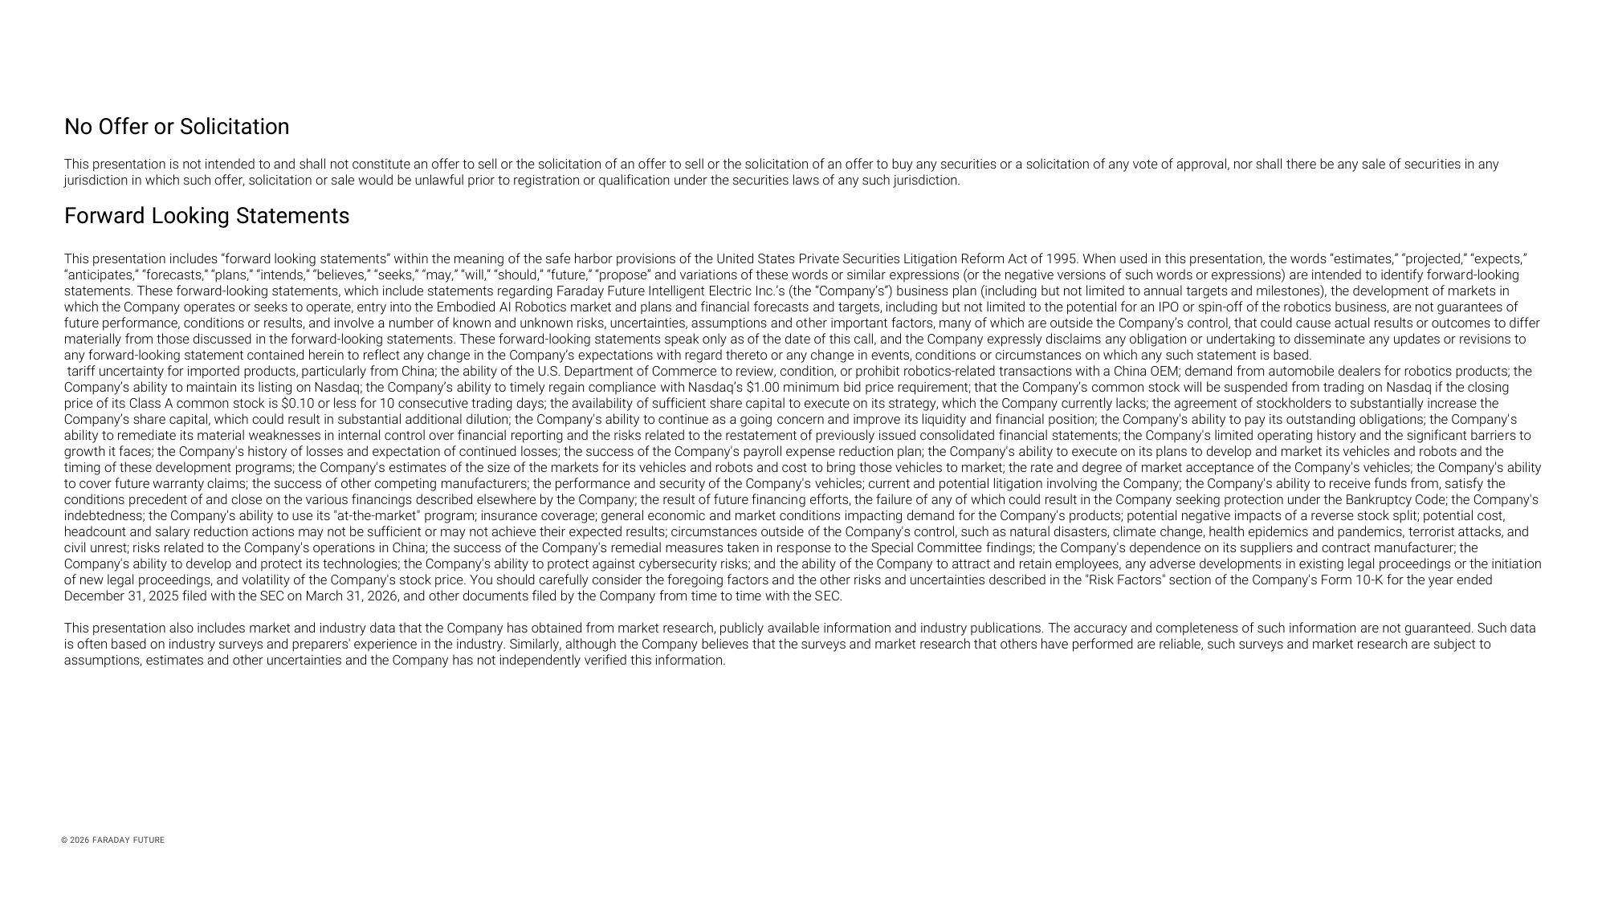
No Offer or Solicitation This presentation is not intended to and shall not constitute an offer to sell or the solicitation of an offer to sell or the solicitation of an offer to buy any securities or a solicitation of any vote of approval, nor shall there be any sale of securities in any jurisdiction in which such offer, solicitation or sale would be unlawful prior to registration or qualification under the securities laws of any such jurisdiction. Forward Looking Statements This presentation includes “forward looking statements” within the meaning of the safe harbor provisions of the United States Private Securities Litigation Reform Act of 1995. When used in this presentation, the words “estimates,” “projected,” “expects,” “anticipates,” “forecasts,” “plans,” “intends,” “believes,” “seeks,” “may,” “will,” “should,” “future,” “propose” and variations of these words or similar expressions (or the negative versions of such words or expressions) are intended to identify forward - looking statements. These forward - looking statements, which include statements regarding Faraday Future Intelligent Electric Inc.’s (the “Company’s”) business plan (including but not limited to annual targets and milestones), the development of markets in which the Company operates or seeks to operate, entry into the Embodied AI Robotics market and plans and financial forecasts and targets, including but not limited to the potential for an IPO or spin - off of the robotics business, are not guarantees of future performance, conditions or results, and involve a number of known and unknown risks, uncertainties, assumptions and other important factors, many of which are outside the Company’s control, that could cause actual results or outcomes to differ materially from those discussed in the forward - looking statements. These forward - looking statements speak only as of the date of this call, and the Company expressly disclaims any obligation or undertaking to disseminate any updates or revisions to any forward - looking statement contained herein to reflect any change in the Company’s expectations with regard thereto or any change in events, conditions or circumstances on which any such statement is based. tariff uncertainty for imported products, particularly from China; the ability of the U.S. Department of Commerce to review, condition, or prohibit robotics - related transactions with a China OEM; demand from automobile dealers for robotics products; the Company’s ability to maintain its listing on Nasdaq; the Company’s ability to timely regain compliance with Nasdaq’s $1.00 minimum bid price requirement; that the Company’s common stock will be suspended from trading on Nasdaq if the closing price of its Class A common stock is $0.10 or less for 10 consecutive trading days; the availability of sufficient share capital to execute on its strategy, which the Company currently lacks; the agreement of stockholders to substantially increase the Company’s share capital, which could result in substantial additional dilution; the Company's ability to continue as a going concern and improve its liquidity and financial position; the Company's ability to pay its outstanding obligations; the Company's ability to remediate its material weaknesses in internal control over financial reporting and the risks related to the restatement of previously issued consolidated financial statements; the Company's limited operating history and the significant barriers to growth it faces; the Company's history of losses and expectation of continued losses; the success of the Company's payroll expense reduction plan; the Company's ability to execute on its plans to develop and market its vehicles and robots and the timing of these development programs; the Company's estimates of the size of the markets for its vehicles and robots and cost to bring those vehicles to market; the rate and degree of market acceptance of the Company's vehicles; the Company's ability to cover future warranty claims; the success of other competing manufacturers; the performance and security of the Company's vehicles; current and potential litigation involving the Company; the Company's ability to receive funds from, satisfy the conditions precedent of and close on the various financings described elsewhere by the Company; the result of future financing efforts, the failure of any of which could result in the Company seeking protection under the Bankruptcy Code; the Company's indebtedness; the Company's ability to use its "at - the - market" program; insurance coverage; general economic and market conditions impacting demand for the Company's products; potential negative impacts of a reverse stock split; potential cost, headcount and salary reduction actions may not be sufficient or may not achieve their expected results; circumstances outside of the Company's control, such as natural disasters, climate change, health epidemics and pandemics, terrorist attacks, and civil unrest; risks related to the Company's operations in China; the success of the Company's remedial measures taken in response to the Special Committee findings; the Company's dependence on its suppliers and contract manufacturer; the Company's ability to develop and protect its technologies; the Company's ability to protect against cybersecurity risks; and the ability of the Company to attract and retain employees, any adverse developments in existing legal proceedings or the initiation of new legal proceedings, and volatility of the Company's stock price. You should carefully consider the foregoing factors and the other risks and uncertainties described in the "Risk Factors" section of the Company's Form 10 - K for the year ended December 31, 2025 filed with the SEC on March 31, 2026, and other documents filed by the Company from time to time with the SEC. This presentation also includes market and industry data that the Company has obtained from market research, publicly available information and industry publications. The accuracy and completeness of such information are not guaranteed. Such data is often based on industry surveys and preparers' experience in the industry. Similarly, although the Company believes that the surveys and market research that others have performed are reliable, such surveys and market research are subject to assumptions, estimates and other uncertainties and the Company has not independently verified this information. © 2026 FARADAY FUTURE

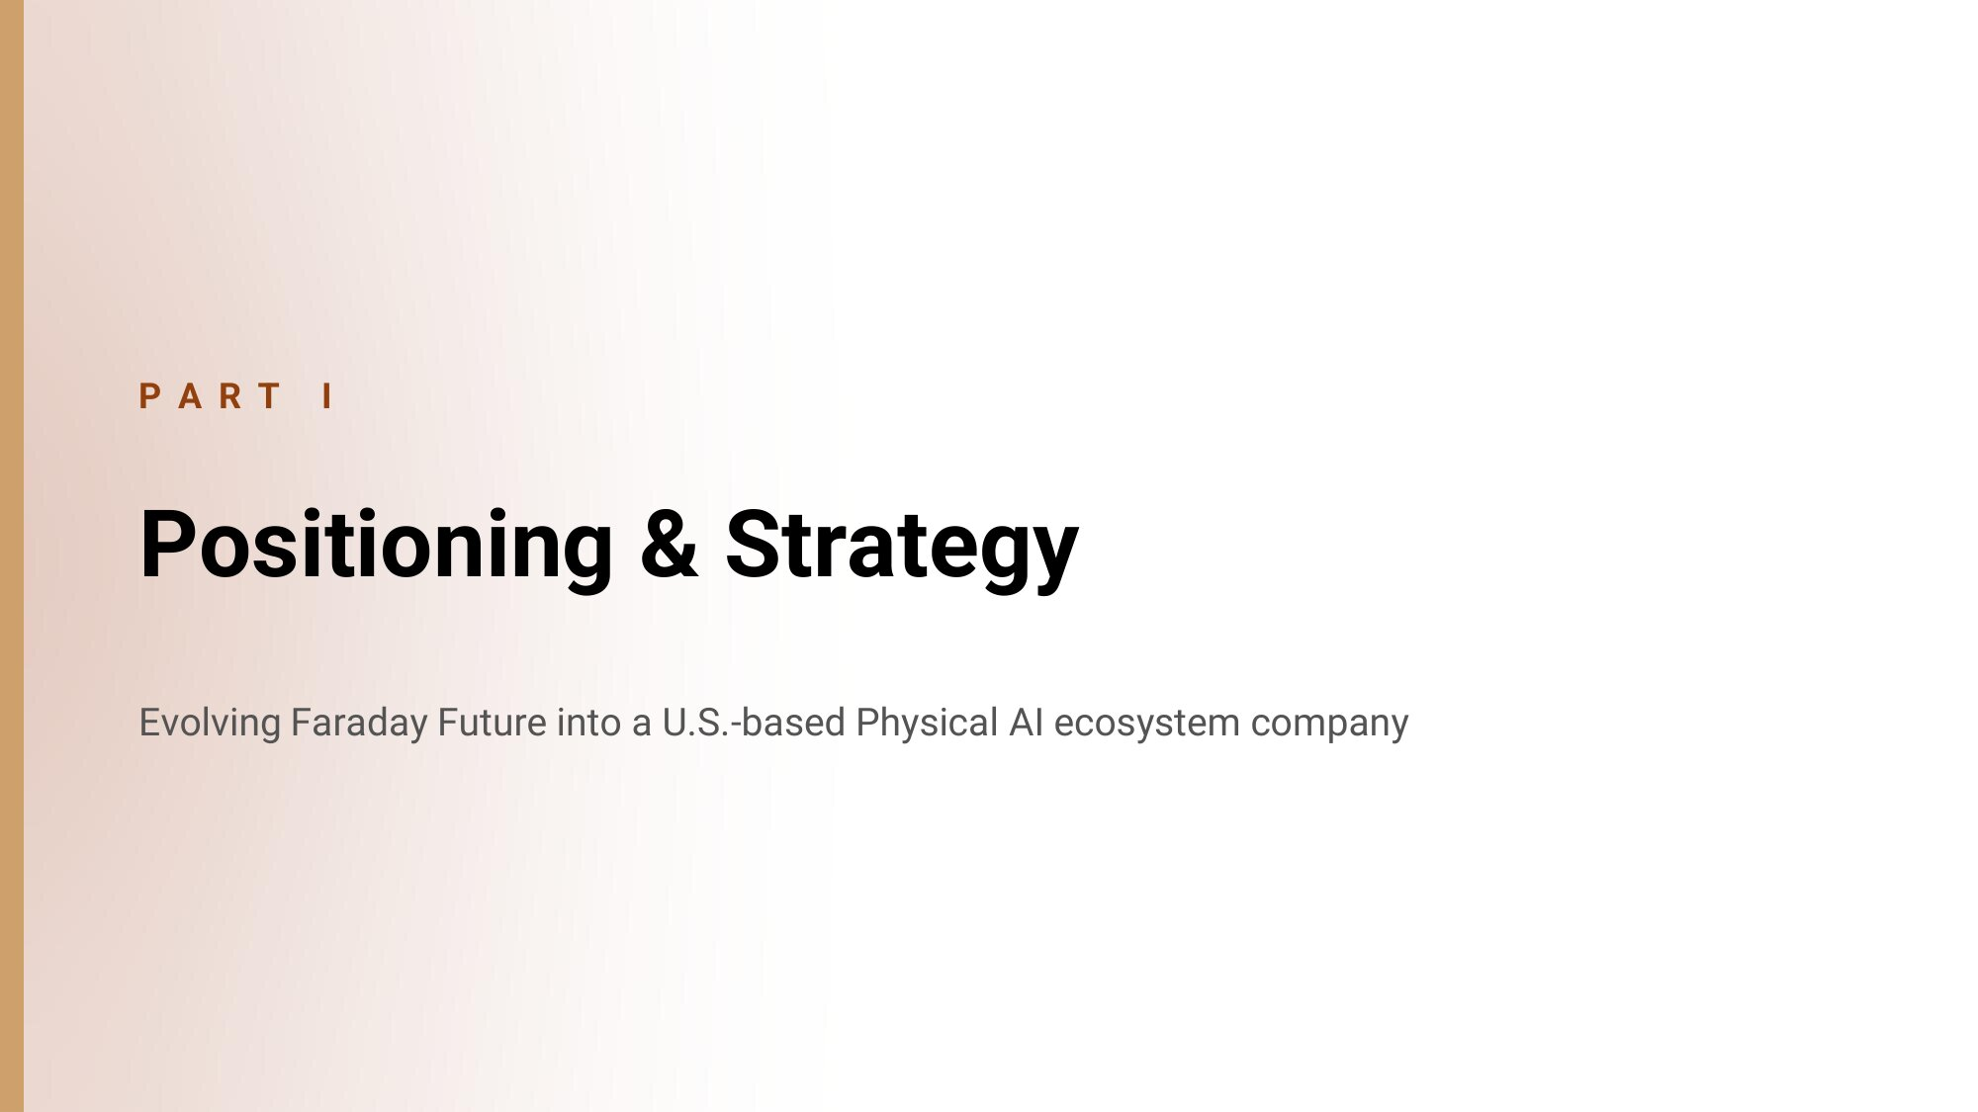
P A R T I Positioning & Strategy Evolving Faraday Future into a U.S. - based Physical AI ecosystem company

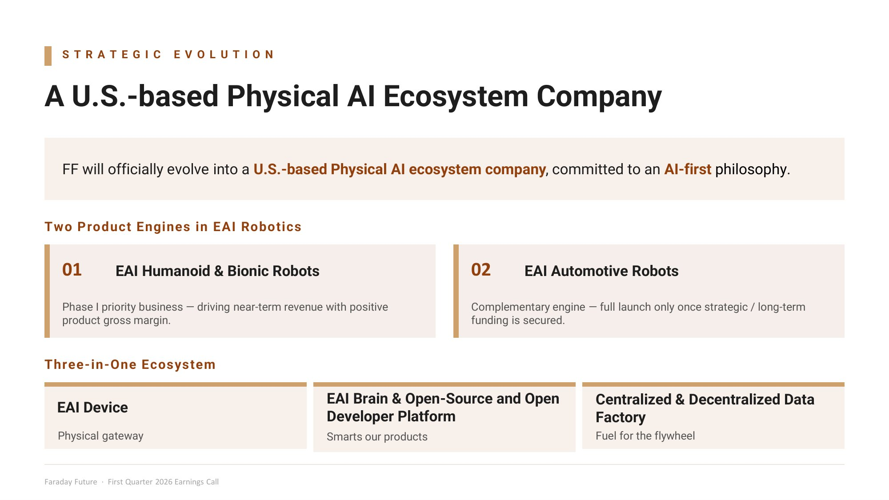
S T R A T E G I C E V O L U T I O N A U.S. - based Physical AI Ecosystem Company FF will officially evolve into a U.S. - based Physical AI ecosystem company , committed to an AI - first philosophy . Two Product Engines in EAI Robotics 01 EAI Humanoid & Bionic Robots Phase I priority business — driving near - term revenue with positive product gross margin. 02 EAI Automotive Robots Complementary engine — full launch only once strategic / long - term funding is secured. Three - in - One Ecosystem EAI Device Physical gateway EAI Brain & Open - Source and Open Developer Platform Smarts our products Centralized & Decentralized Data Factory Fuel for the flywheel Faraday Future · First Quarter 2026 Earnings Call

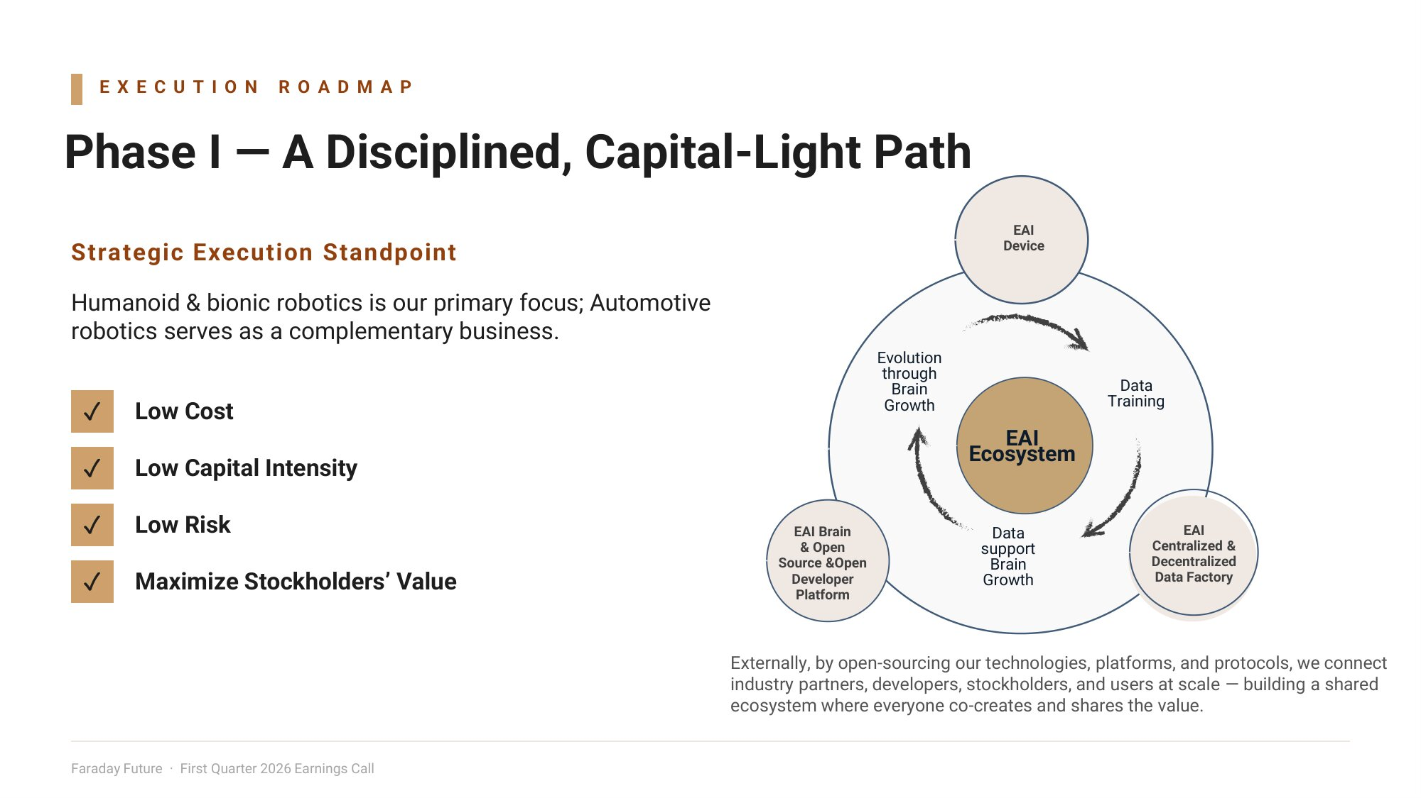
E X E C U T I O N R O A D M A P Phase I — A Disciplined, Capital - Light Path Strategic Execution Standpoint Humanoid & bionic robotics is our primary focus; Automotive robotics serves as a complementary business. ض Low Cost ض Low Capital Intensity ض Low Risk ض Maximize Stockholders’ Value EAI Faraday Future · First Quarter 2026 Earnings Call Ecosystem EAI Device Data Training EAI Centralized & Decentralized Data Factory EAI Brain & Open Source &Open Developer Platform Evolution through Brain Growth Data support Brain Growth Externally, by open - sourcing our technologies, platforms, and protocols, we connect industry partners, developers, stockholders, and users at scale — building a shared ecosystem where everyone co - creates and shares the value.

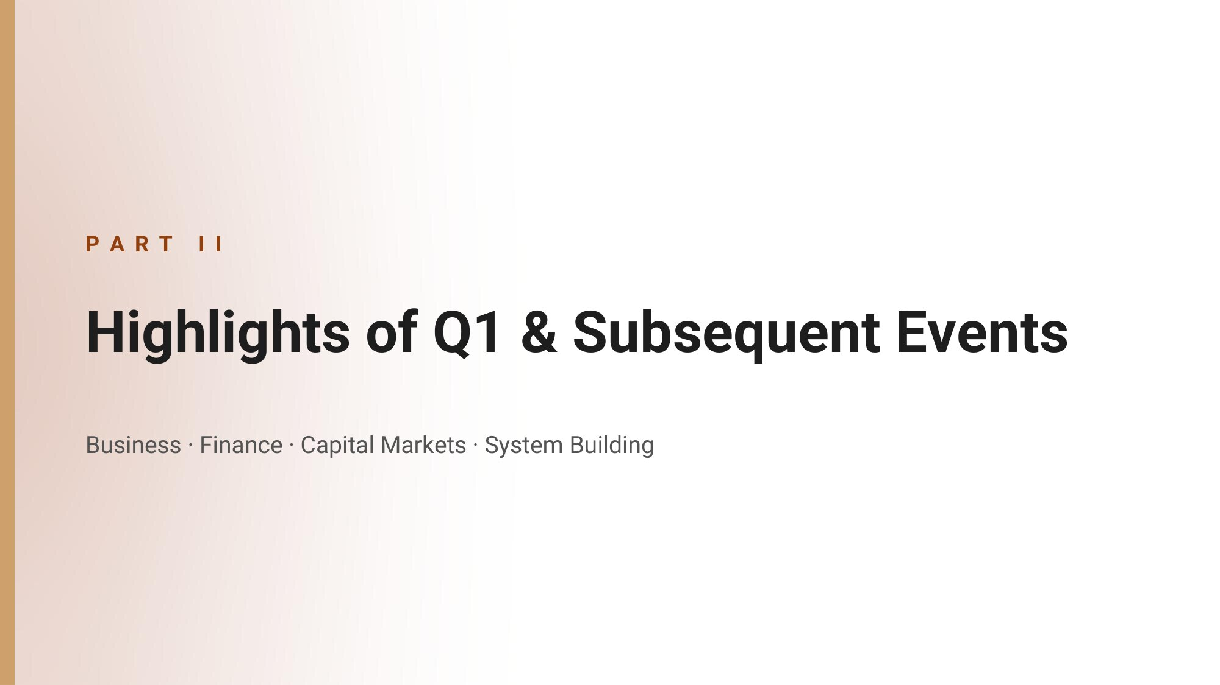
P A R T I I Highlights of Q1 & Subsequent Events Business · Finance · Capital Markets · System Building

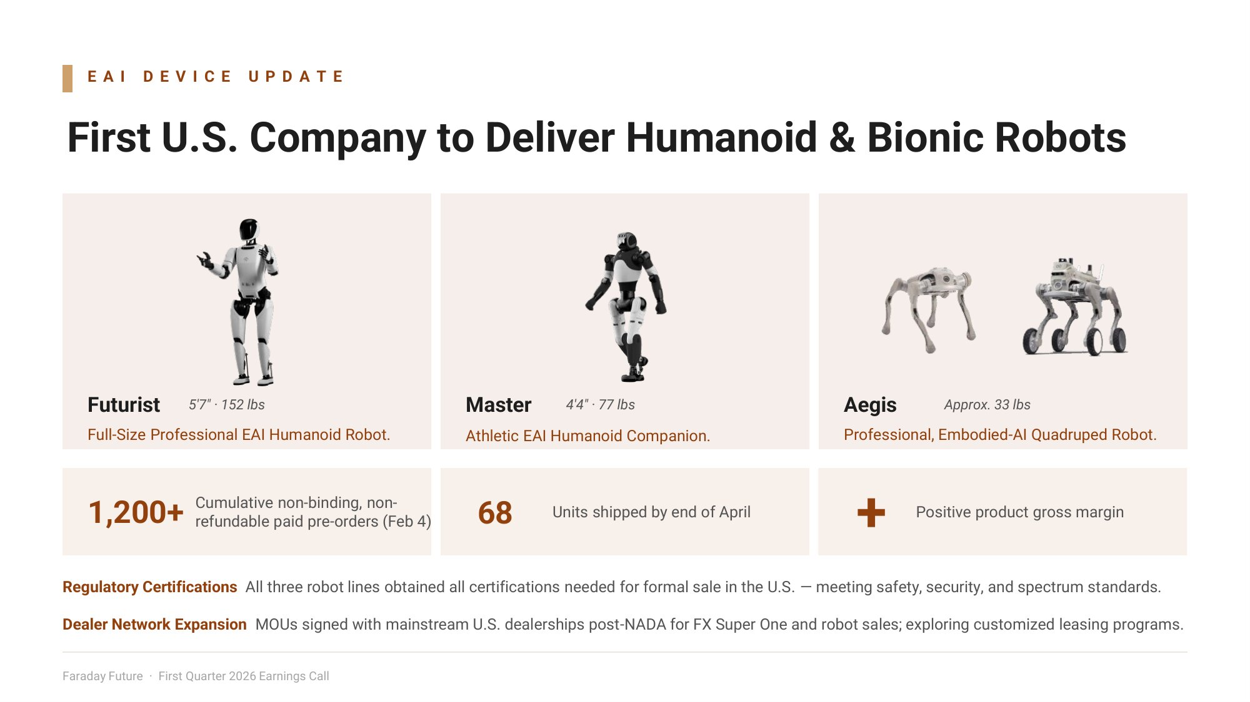
E A I D E V I C E U P D A T E First U.S. Company to Deliver Humanoid & Bionic Robots Futurist Full - Size Professional EAI Humanoid Robot. Master Athletic EAI Humanoid Companion. Aegis Professional, Embodied - AI Quadruped Robot. 1,200+ Cumulative non - binding, non - refundable paid pre - orders (Feb 4) 68 Units shipped by end of April + Positive product gross margin Regulatory Certifications All three robot lines obtained all certifications needed for formal sale in the U.S. — meeting safety, security, and spectrum standards. Dealer Network Expansion MOUs signed with mainstream U.S. dealerships post - NADA for FX Super One and robot sales; exploring customized leasing programs. 5'7" · 152 lbs 4'4" · 77 lbs Approx. 33 lbs Faraday Future · First Quarter 2026 Earnings Call

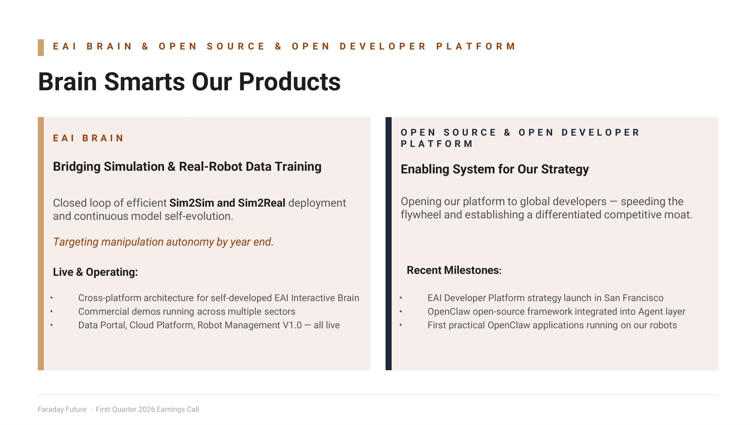
E A I B R A I N & O P E N S O U R C E & O P E N D E V E L O P E R P L A T F O R M Brain Smarts Our Products E A I B R A I N Bridging Simulation & Real - Robot Data Training Closed loop of efficient Sim2Sim and Sim2Real deployment and continuous model self - evolution. Targeting manipulation autonomy by year end. Live & Operating: • Cross - platform architecture for self - developed EAI Interactive Brain • Commercial demos running across multiple sectors • Data Portal, Cloud Platform, Robot Management V1.0 — all live O P E N S O U R C E & O P E N D E V E L O P E R P L A T F O R M Enabling System for Our Strategy Opening our platform to global developers — speeding the flywheel and establishing a differentiated competitive moat. Recent Milestones : • EAI Developer Platform strategy launch in San Francisco • OpenClaw open - source framework integrated into Agent layer • First practical OpenClaw applications running on our robots Faraday Future · First Quarter 2026 Earnings Call

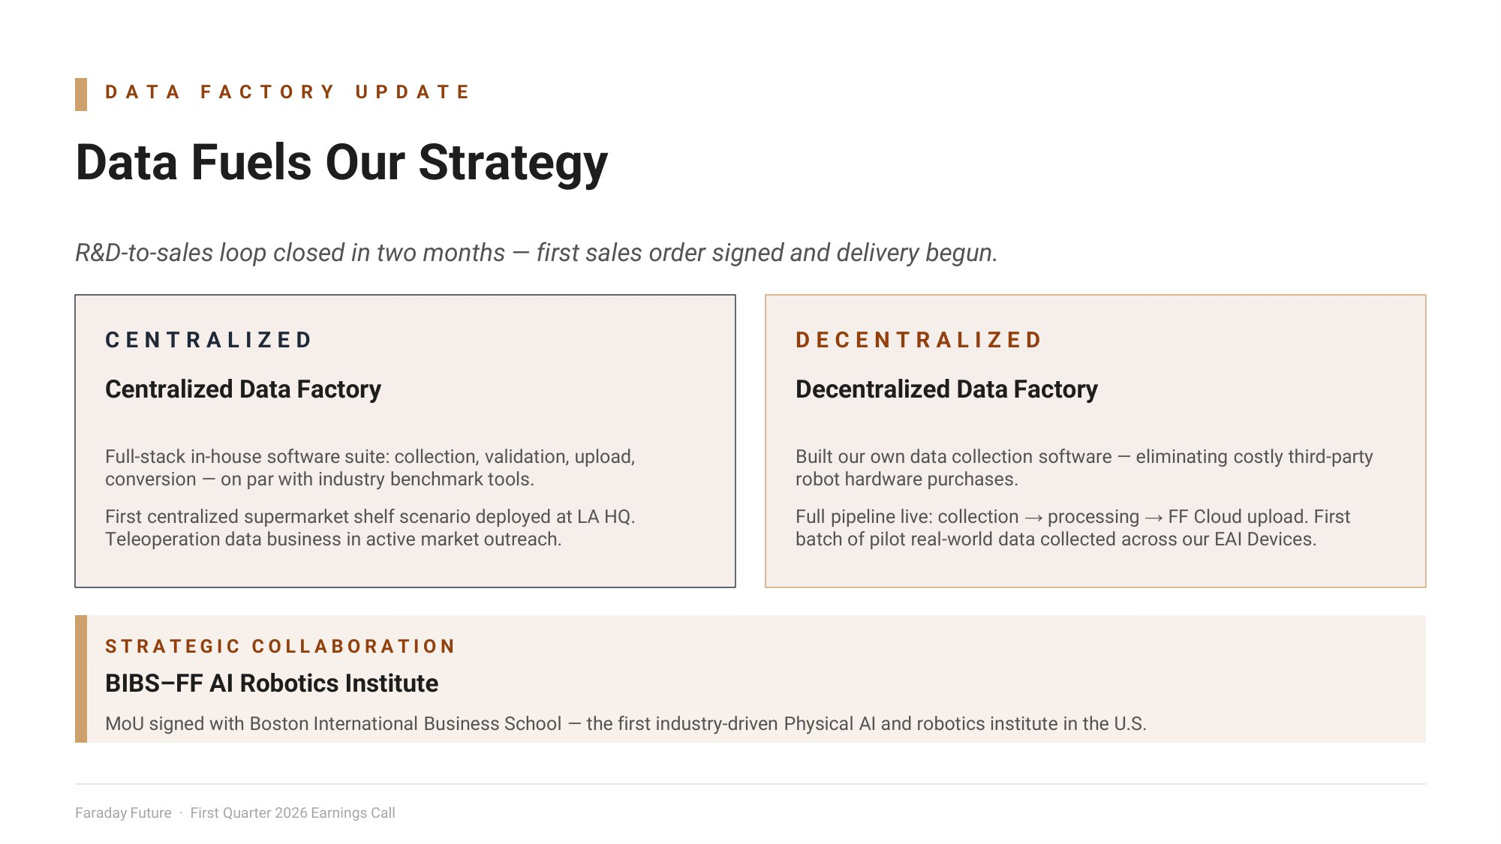
D A T A F A C T O R Y U P D A T E Data Fuels Our Strategy R&D - to - sales loop closed in t o months — first sales order signed and delivery begun. D E C E N T R A L I Z E D Decentralized Data Factory Built our own data collection software — eliminating costly third - party robot hardware purchases. Full pipeline live: collection → processing → FF Cloud upload. First batch of pilot real - world data collected across our EAI Devices. C E N T R A L I Z E D Centralized Data Factory Full - stack in - house software suite: collection, validation, upload, conversion — on par with industry benchmark tools. First centralized supermarket shelf scenario deployed at LA HQ. Teleoperation data business in active market outreach. S T R A T E G I C C O L L A B O R A T I O N BIBS – FF AI Robotics Institute MoU signed with Boston International Business School — the first industry - driven Physical AI and robotics institute in the U.S. Faraday Future · First Quarter 2026 Earnings Call

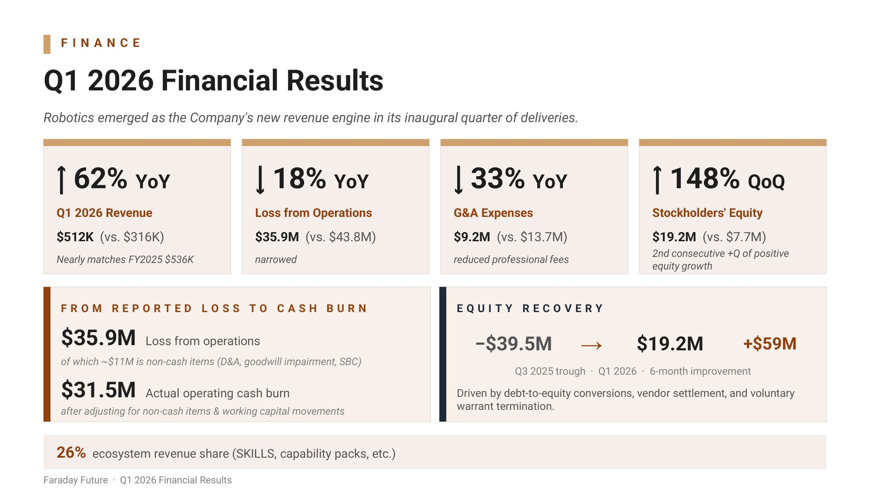
F I N A N C E Q1 2026 Financial Results Robotics emerged as the Company's ne revenue engine in its inaugural quarter of deliveries. ↑ 62% YoY Q1 2026 Revenue $512K (vs. $316K) Nearly matches FY2025 $536K ↓ 18% YoY Loss from Operations $35.9M (vs. $43.8M) narro ed ↓ 33% YoY G&A Expenses $9.2M (vs. $13.7M) reduced professional fees ↑ 148% QoQ Stockholders' Equity $19.2M (vs. $7.7M) 2nd consecutive +Q of positive equity gro th F R O M R E P O R T E D L O S S T O C A S H B U R N $35.9M Loss from operations of hich ~$11M is non - cash items (D&A, good ill impairment, SBC) $31.5M Actual operating cash burn after adjusting for non - cash items & orking capital movements E Q U I T Y R E C O V E R Y −$39.5M → $19.2M +$59M Q3 2025 trough · Q1 2026 · 6 - month improvement Driven by debt - to - equity conversions, vendor settlement, and voluntary warrant termination. 26% ecosystem revenue share (SKILLS, capability packs, etc.) Faraday Future · Q1 2026 Financial Results

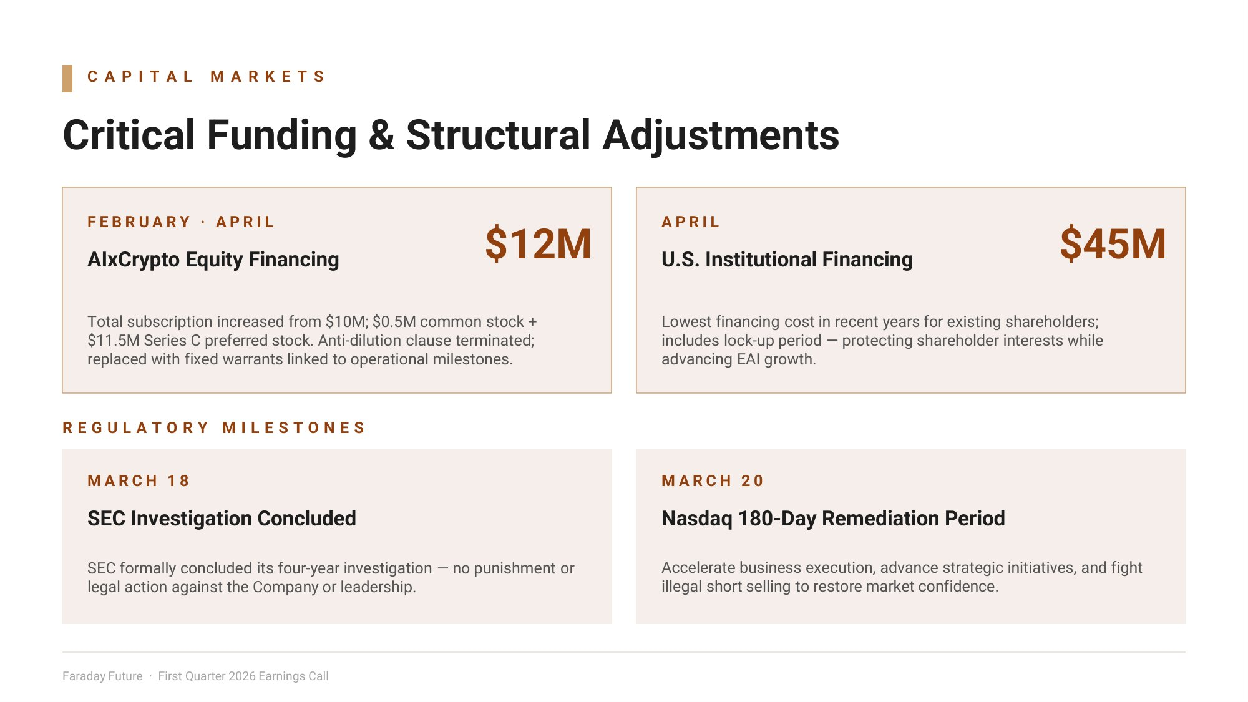
C A P I T A L M A R K E T S Critical Funding & Structural Adjustments $12M F E B R U A R Y · A P R I L AIxCrypto Equity Financing Total subscription increased from $10M; $0.5M common stock + $11.5M Series C preferred stock. Anti - dilution clause terminated; replaced with fixed warrants linked to operational milestones. A P R I L U.S. Institutional Financing $45M Lowest financing cost in recent years for existing shareholders; includes lock - up period — protecting shareholder interests while advancing EAI growth. R E G U L A T O R Y M I L E S T O N E S M A R C H 1 8 SEC Investigation Concluded SEC formally concluded its four - year investigation — no punishment or legal action against the Company or leadership. M A R C H 2 0 Nasdaq 180 - Day Remediation Period Accelerate business execution, advance strategic initiatives, and fight illegal short selling to restore market confidence. Faraday Future · First Quarter 2026 Earnings Call

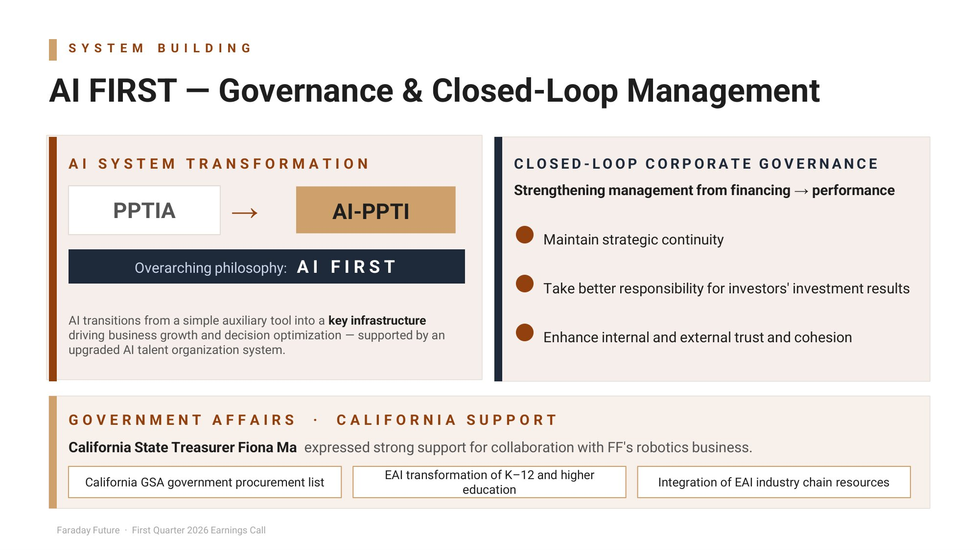
S Y S T E M B U I L D I N G AI FIRST — Governance & Closed - Loop Management PPTIA Overarching philosophy : A I F I R S T A I S Y S T E M T R A N S F O R M A T I O N → AI transitions from a simple auxiliary tool into a key infrastructure driving business growth and decision optimization — supported by an upgraded AI talent organization system. C L O S E D - L O O P C O R P O R A T E G O V E R N A N C E Strengthening management from financing → performance Maintain strategic continuity Take better responsibility for investors' investment results Enhance internal and external trust and cohesion G O V E R N M E N T A F F A I R S · C A L I F O R N I A S U P P O R T California State Treasurer Fiona Ma expressed strong support for collaboration with FF's robotics business. Faraday Future · First Quarter 2026 Earnings Call California GSA government procurement list EAI transformation of K – 12 and higher education Integration of EAI industry chain resources AI - PPTI

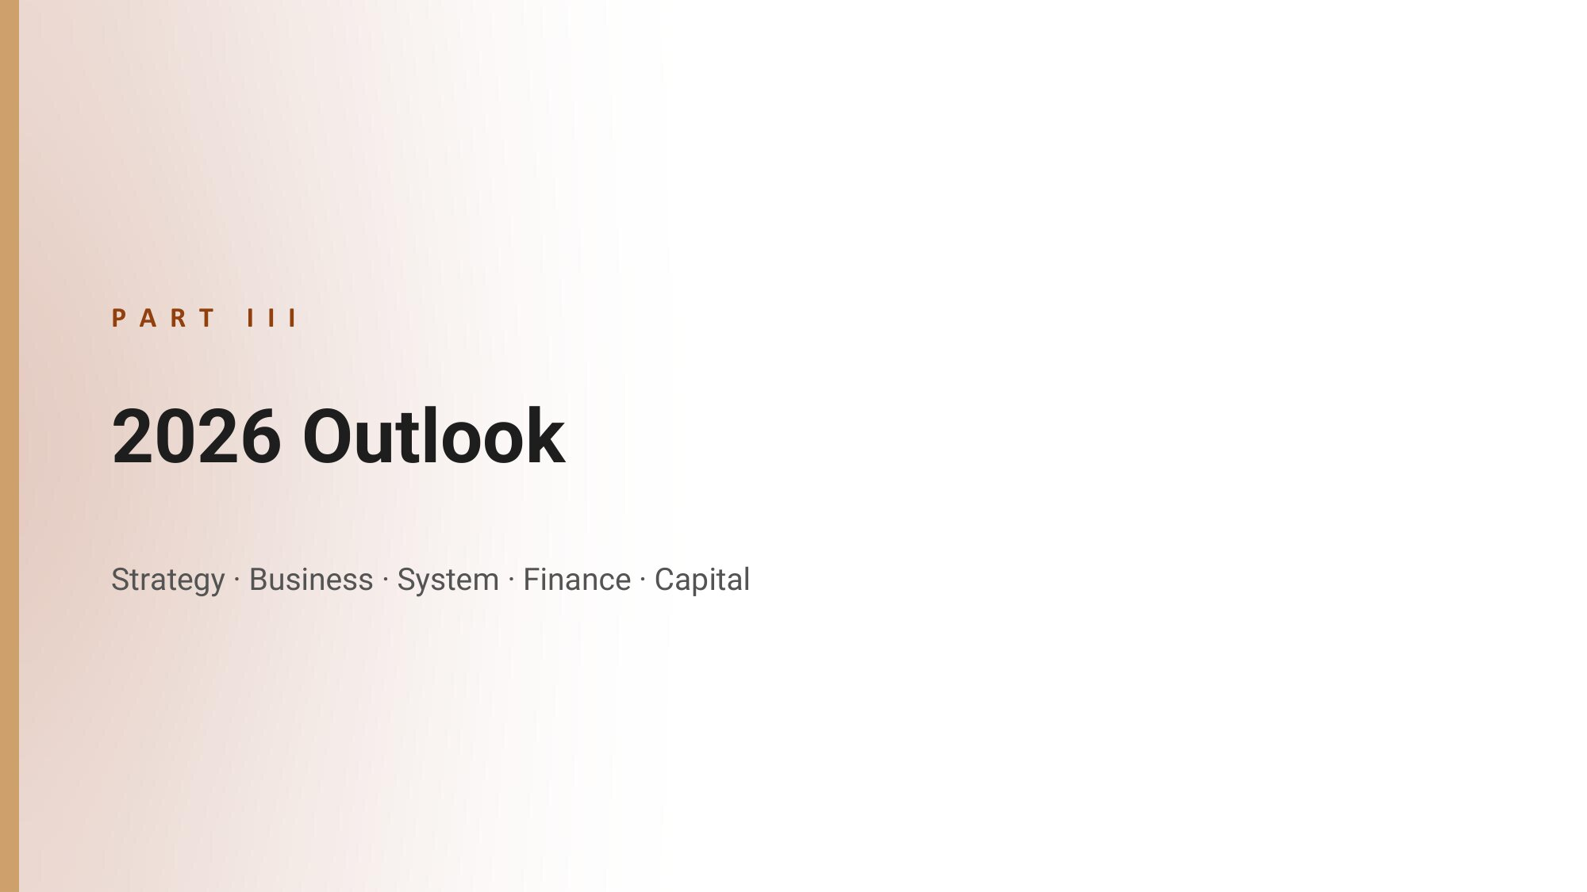
P A R T I I I 2026 Outlook Strategy · Business · System · Finance · Capital

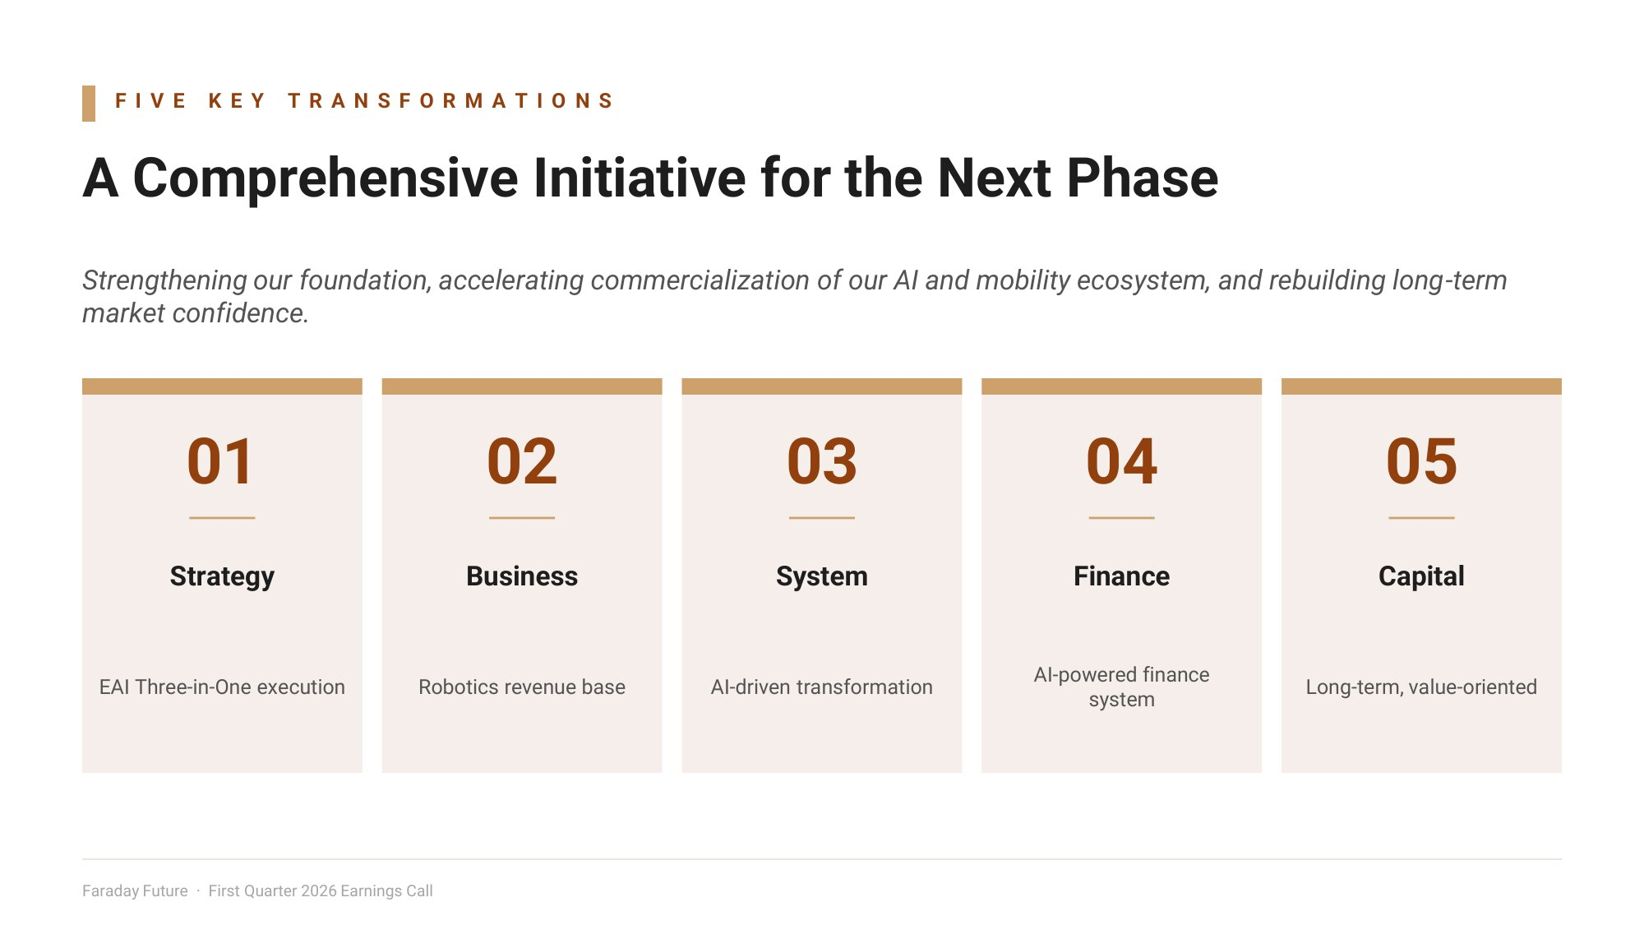
F I V E K E Y T R A N S F O R M A T I O N S A Comprehensive Initiative for the Next Phase Strengthening our foundation, accelerating commercialization of our AI and mobility ecosystem, and rebuilding long - term market confidence. 01 Strategy EAI Three - in - One execution 02 Business Robotics revenue base 03 System AI - driven transformation 04 Finance AI - powered finance system 05 Capital Long - term, value - oriented Faraday Future · First Quarter 2026 Earnings Call

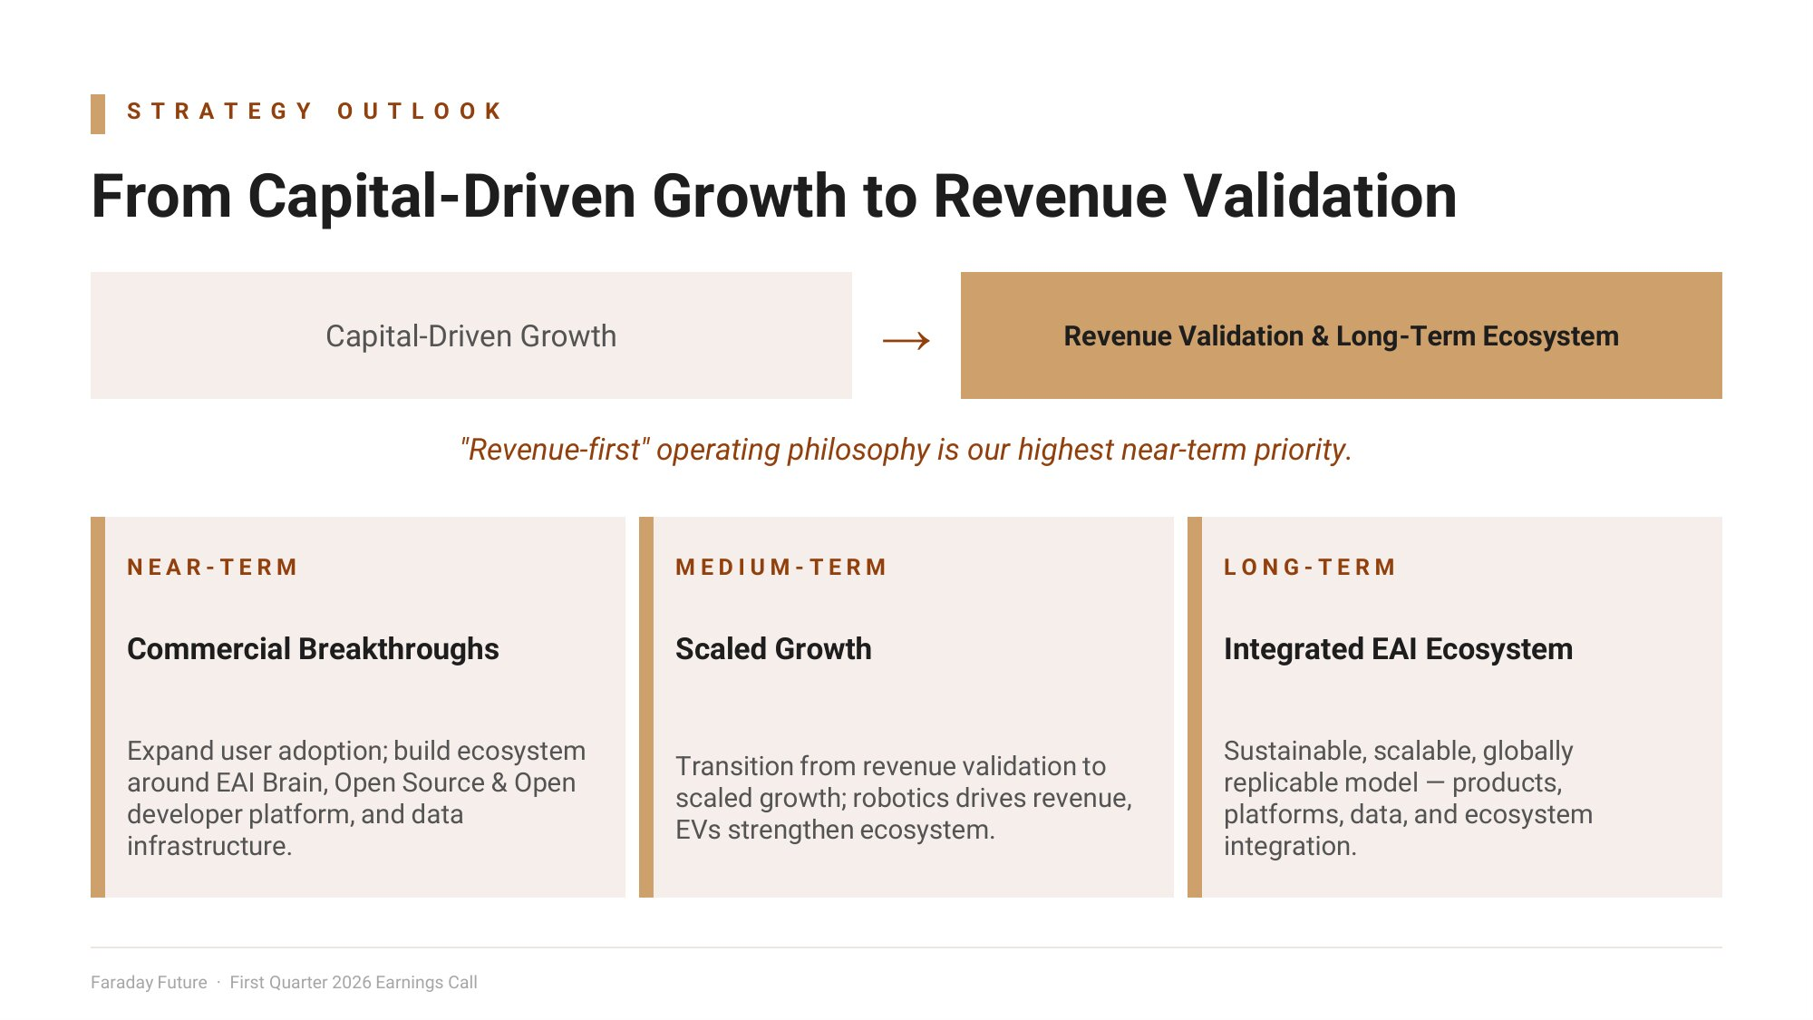
S T R A T E G Y O U T L O O K From Capital - Driven Growth to Revenue Validation Capital - Driven Growth → Revenue Validation & Long - Term Ecosystem "Revenue - first" operating philosophy is our highest near - term priority. N E A R - T E R M Commercial Breakthroughs Expand user adoption; build ecosystem around EAI Brain, Open Source & Open developer platform, and data infrastructure. M E D I U M - T E R M Scaled Growth Transition from revenue validation to scaled growth; robotics drives revenue, EVs strengthen ecosystem. L O N G - T E R M Integrated EAI Ecosystem Sustainable, scalable, globally replicable model — products, platforms, data, and ecosystem integration. Faraday Future · First Quarter 2026 Earnings Call

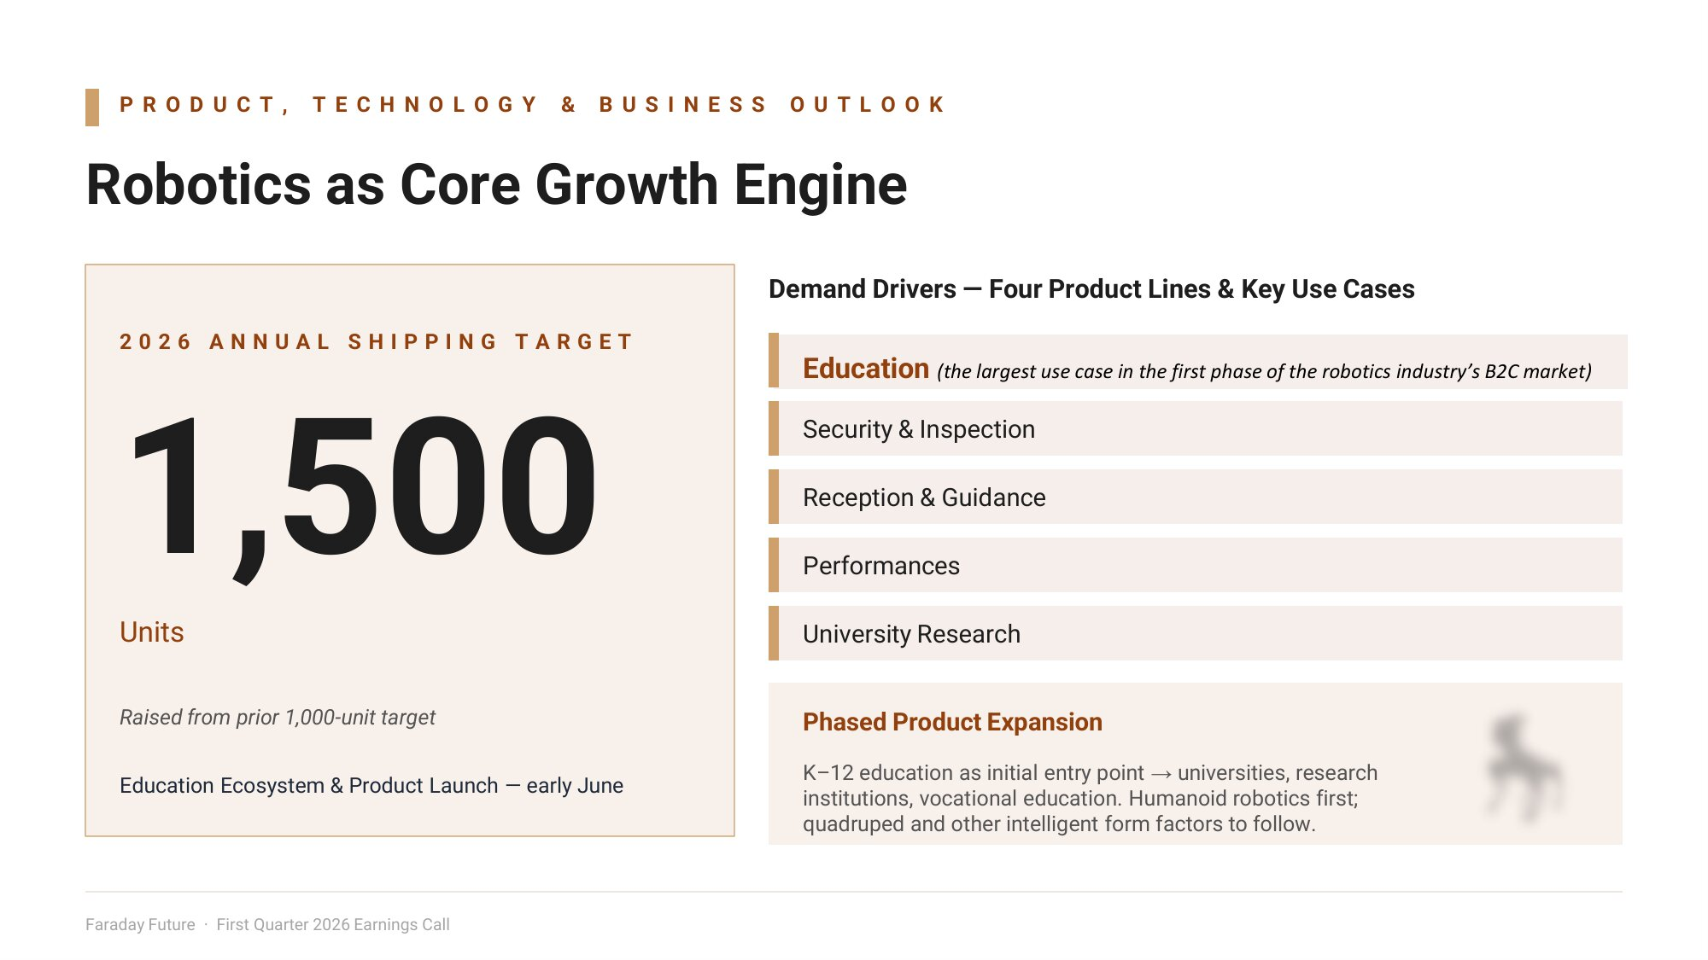
P R O D U C T , T E C H N O L O G Y & B U S I N E S S O U T L O O K Robotics as Core Growth Engine 2 0 2 6 A N N U A L S H I P P I N G T A R G E T 1,500 Units Raised from prior 1,000 - unit target Education Ecosystem & Product Launch — early June Demand Drivers — Four Product Lines & Key Use Cases Education (the largest use case in the first phase of the robotics industry’s B2C market) Security & Inspection Reception & Guidance Performances University Research Phased Product Expansion K – 12 education as initial entry point → universities, research institutions, vocational education. Humanoid robotics first; quadruped and other intelligent form factors to follow. Faraday Future · First Quarter 2026 Earnings Call

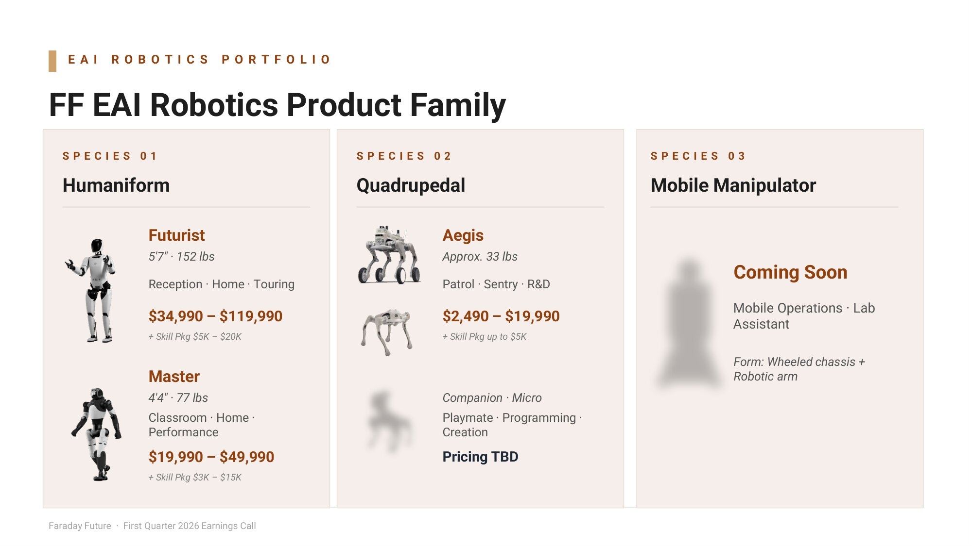
E A I R O B O T I C S P O R T F O L I O FF EAI Robotics Product Family S P E C I E S 0 1 Humaniform Futurist 5'7" · 152 lbs Reception · Home · Touring $34,990 – $119,990 + Skill Pkg $5K – $20K Master 4'4" · 77 lbs Classroom · Home · Performance $19,990 – $49,990 + Skill Pkg $3K – $15K S P E C I E S 0 2 Quadrupedal Aegis Approx. 33 lbs Patrol · Sentry · R&D $2,490 – $19,990 + Skill Pkg up to $5K Companion · Micro Playmate · Programming · Creation Pricing TBD S P E C I E S 0 3 Mobile Manipulator Coming Soon Mobile Operations · Lab Assistant Form: Wheeled chassis + Robotic arm Faraday Future · First Quarter 2026 Earnings Call

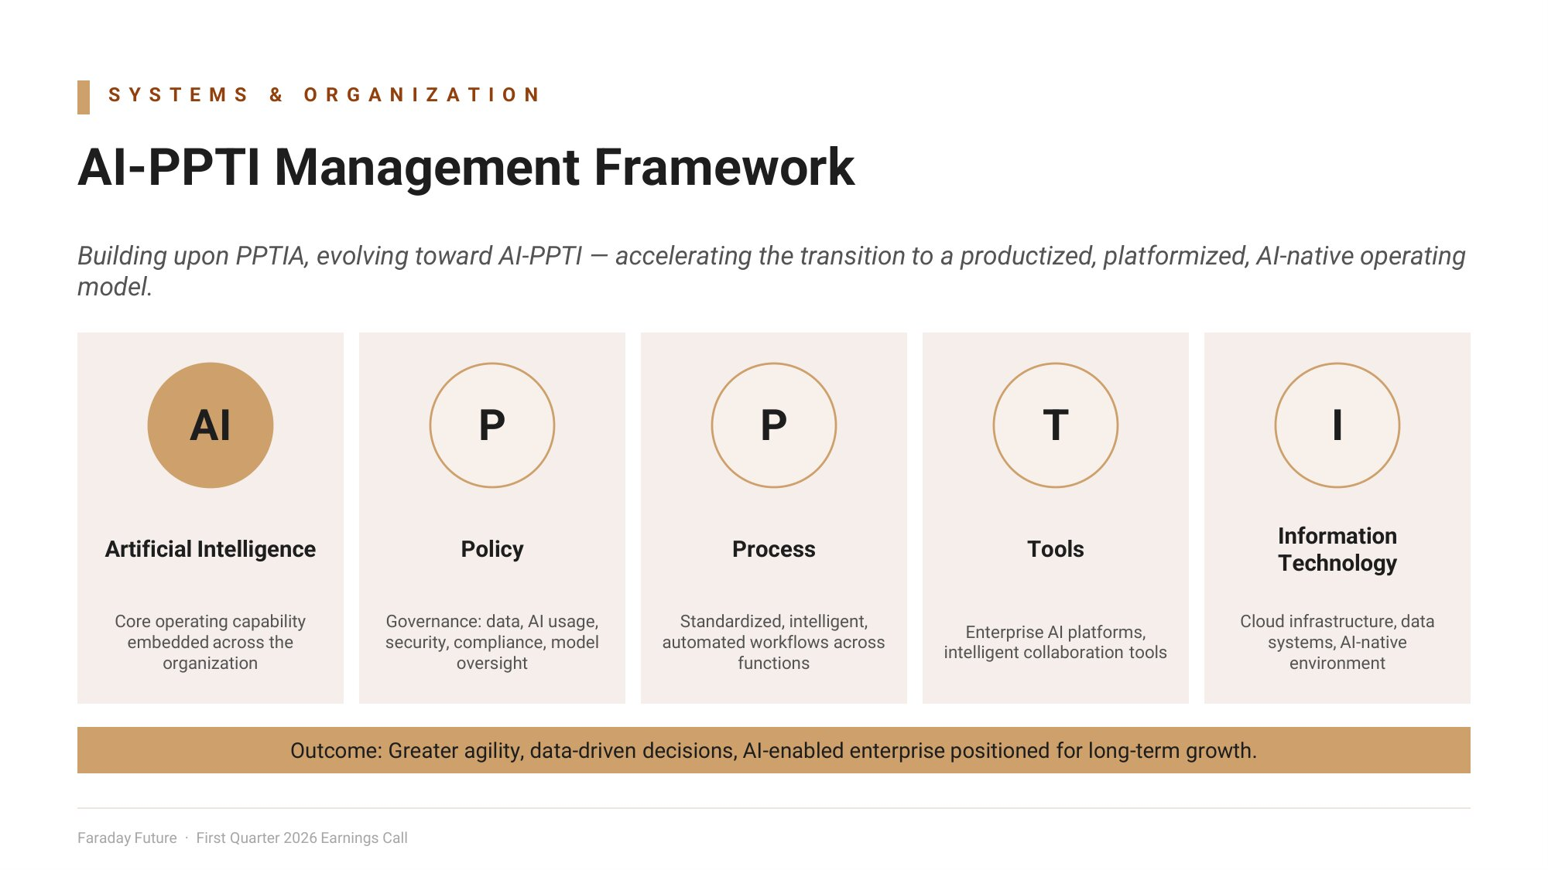
S Y S T E M S & O R G A N I Z A T I O N AI - PPTI Management Framework Building upon PPTIA, evolving to ard AI - PPTI — accelerating the transition to a productized, platformized, AI - native operating model. AI Artificial Intelligence Core operating capability embedded across the organization P Policy Governance: data, AI usage, security, compliance, model oversight P Process Standardized, intelligent, automated workflows across functions T Tools Enterprise AI platforms, intelligent collaboration tools I Information Technology Cloud infrastructure, data systems, AI - native environment Outcome: Greater agility, data - driven decisions, AI - enabled enterprise positioned for long - term growth. Faraday Future · First Quarter 2026 Earnings Call

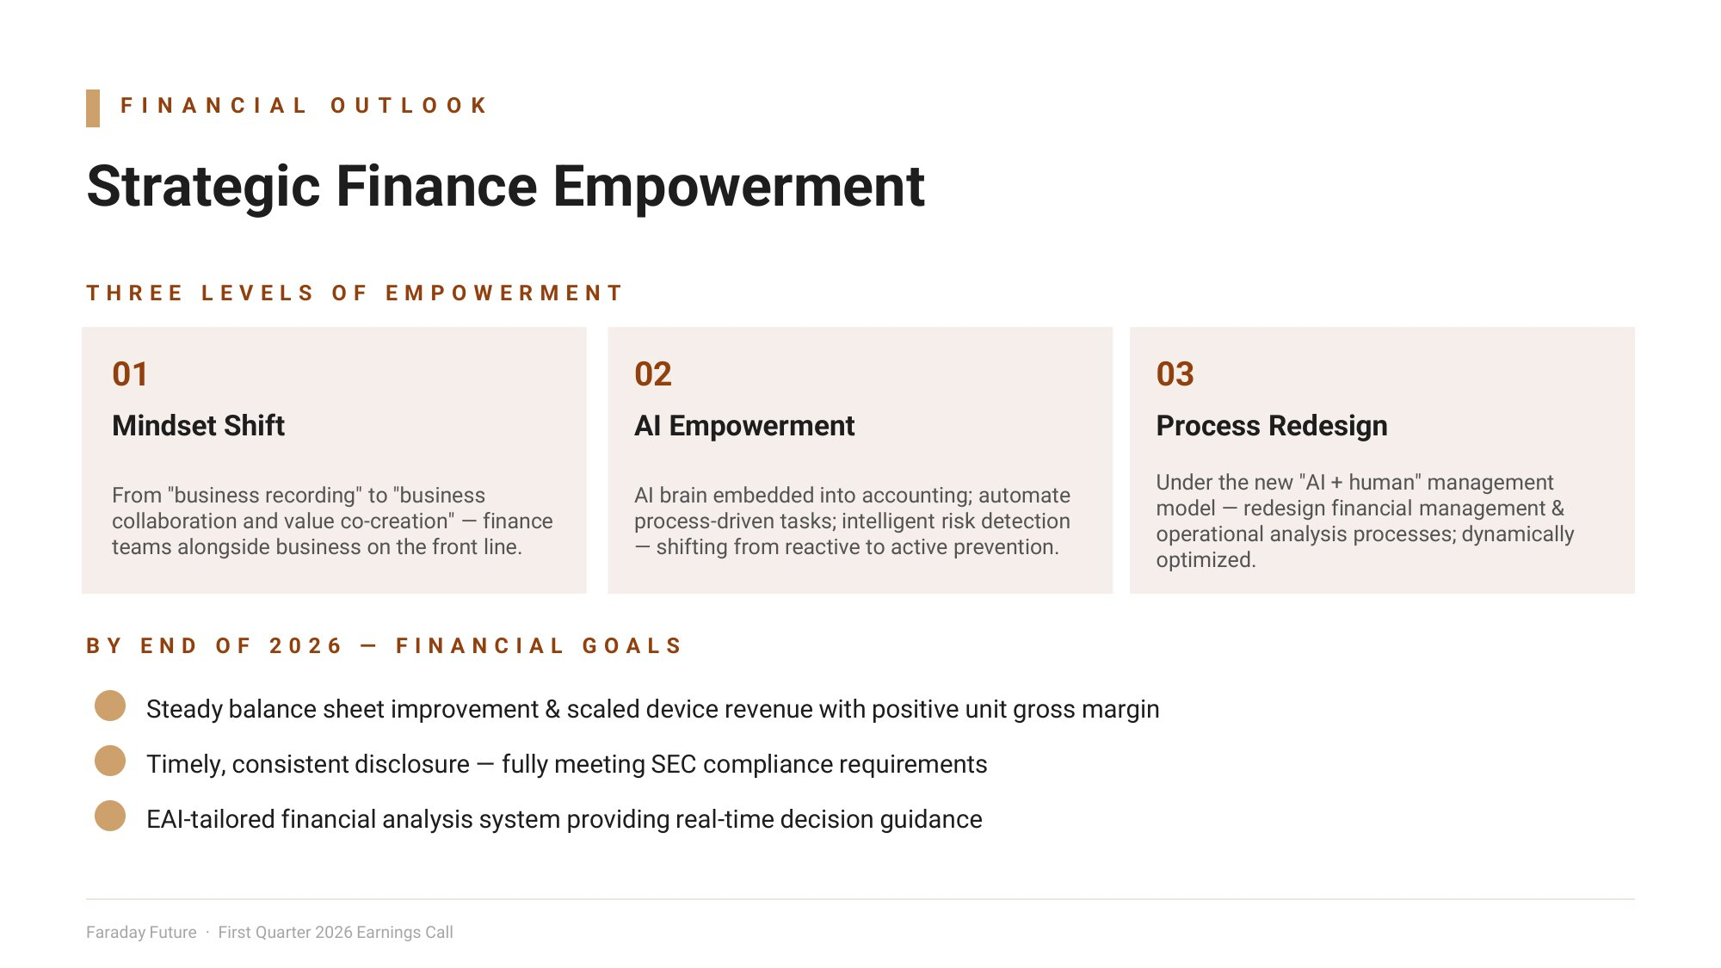
F I N A N C I A L O U T L O O K Strategic Finance Empowerment T H R E E L E V E L S O F E M P O W E R M E N T 01 Mindset Shift From "business recording" to "business collaboration and value co - creation" — finance teams alongside business on the front line. 02 AI Empowerment AI brain embedded into accounting; automate process - driven tasks; intelligent risk detection — shifting from reactive to active prevention. 03 Process Redesign Under the new "AI + human" management model — redesign financial management & operational analysis processes; dynamically optimized. B Y E N D O F 2 0 2 6 — F I N A N C I A L G O A L S Steady balance sheet improvement & scaled device revenue with positive unit gross margin Timely, consistent disclosure — fully meeting SEC compliance requirements EAI - tailored financial analysis system providing real - time decision guidance Faraday Future · First Quarter 2026 Earnings Call

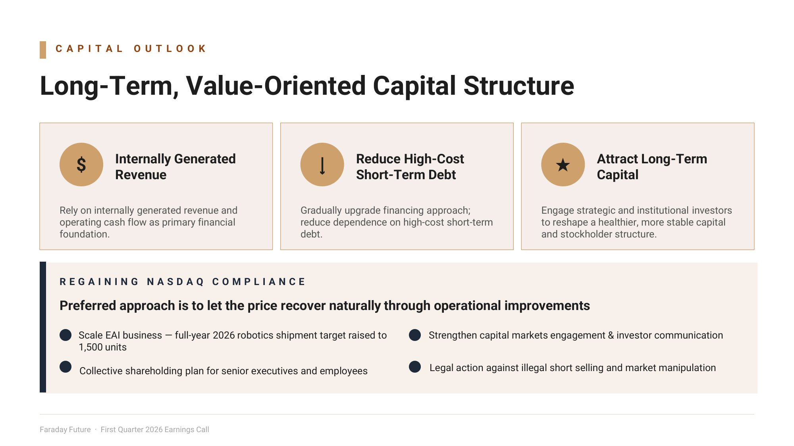
C A P I T A L O U T L O O K Long - Term, Value - Oriented Capital Structure $ Internally Generated Revenue Rely on internally generated revenue and operating cash flow as primary financial foundation . ↓ Reduce High - Cost Short - Term Debt Gradually upgrade financing approach; reduce dependence on high - cost short - term debt. մ Attract Long - Term Capital Engage strategic and institutional investors to reshape a healthier, more stable capital and stockholder structure. R E G A I N I N G N A S D A Q C O M P L I A N C E Preferred approach is to let the price recover naturally through operational improvements Scale EAI business — full - year 2026 robotics shipment target raised to Strengthen capital markets engagement & investor communication 1,500 units Collective shareholding plan for senior executives and employees Legal action against illegal short selling and market manipulation Faraday Future · First Quarter 2026 Earnings Call

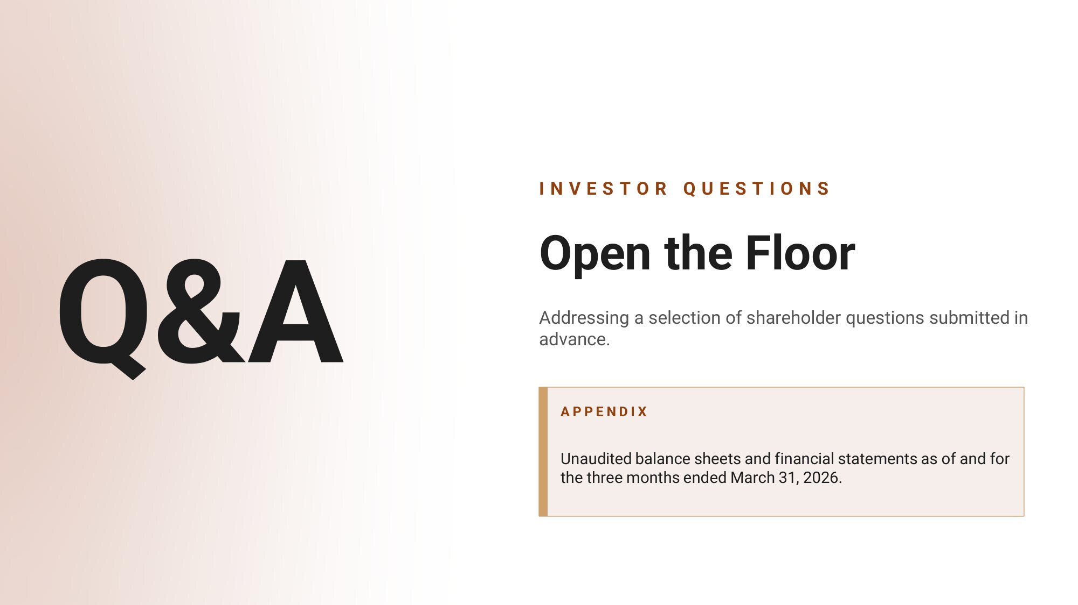
Q& A I N V E S T O R Q U E S T I O N S Open the Floor Addressing a selection of shareholder questions submitted in advance. A P P E N D I X Unaudited balance sheets and financial statements as of and for the three months ended March 31, 2026.

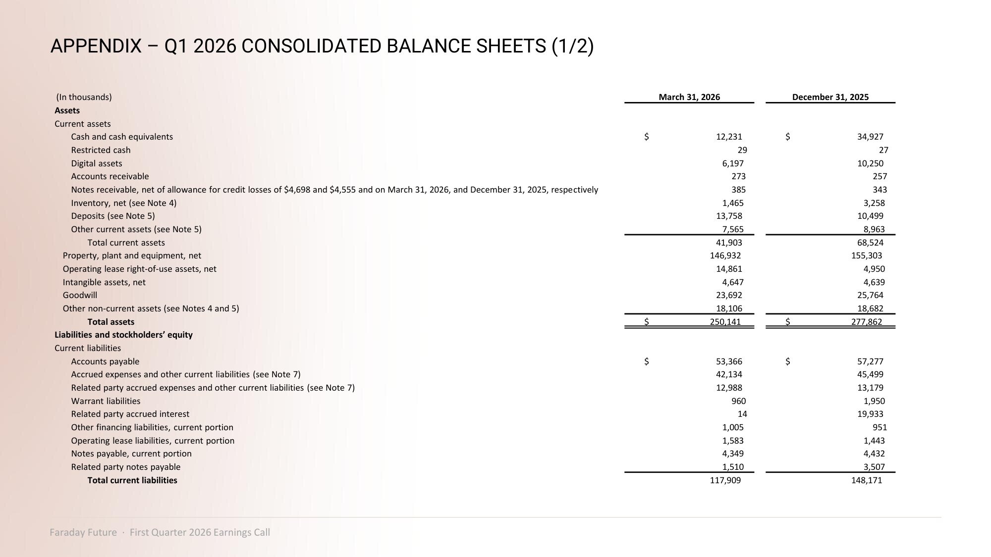
APPENDIX – Q1 2026 CONSOLIDATED BALANCE SHEETS (1/2) December 31, 2025 March 31, 2026 (In thousands) Assets Current assets $ 34,927 $ 12,231 Cash and cash equivalents 27 29 Restricted cash 10,250 6,197 Digital assets 257 273 Accounts receivable 343 385 Notes receivable, net of allowance for credit losses of $4,698 and $4,555 and on March 31, 2026, and December 31, 2025, respectively 3,258 1,465 Inventory, net (see Note 4) 10,499 13,758 Deposits (see Note 5) 8,963 7,565 Other current assets (see Note 5) 68,524 41,903 Total current assets 155,303 146,932 Property, plant and equipment, net 4,950 14,861 Operating lease right - of - use assets, net 4,639 4,647 Intangible assets, net 25,764 23,692 Goodwill 18,682 18,106 Other non - current assets (see Notes 4 and 5) $ 277,862 $ 250,141 Total assets Liabilities and stockholders’ equity Current liabilities $ 57,277 $ 53,366 Accounts payable 45,499 42,134 Accrued expenses and other current liabilities (see Note 7) 13,179 12,988 Related party accrued expenses and other current liabilities (see Note 7) 1,950 960 Warrant liabilities 19,933 14 Related party accrued interest 951 1,005 Other financing liabilities, current portion 1,443 1,583 Operating lease liabilities, current portion 4,432 4,349 Notes payable, current portion 3,507 1,510 Related party notes payable 148,171 117,909 Total current liabilities Faraday Future · First Quarter 2026 Earnings Call

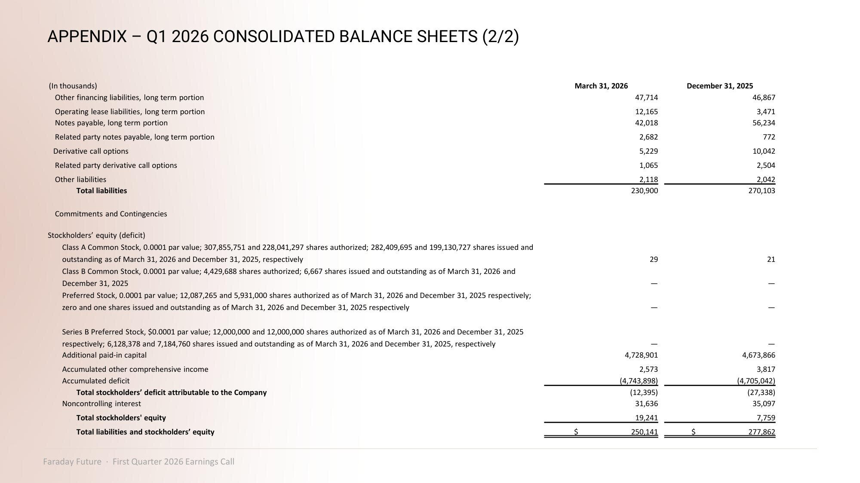
APPENDIX – Q1 2026 CONSOLIDATED BALANCE SHEETS (2/2) December 31, 2025 March 31, 2026 (In thousands) 46,867 47,714 Other financing liabilities, long term portion 3,471 12,165 Operating lease liabilities, long term portion 56,234 42,018 Notes payable, long term portion 772 2,682 Related party notes payable, long term portion 10,042 5,229 Derivative call options 2,504 1,065 Related party derivative call options 2,042 2,118 Other liabilities 270,103 230,900 Total liabilities Commitments and Contingencies Stockholders’ equity (deficit) 21 29 Class A Common Stock, 0.0001 par value; 307,855,751 and 228,041,297 shares authorized; 282,409,695 and 199,130,727 shares issued and outstanding as of March 31, 2026 and December 31, 2025, respectively — — Class B Common Stock, 0.0001 par value; 4,429,688 shares authorized; 6,667 shares issued and outstanding as of March 31, 2026 and December 31, 2025 — — Preferred Stock, 0.0001 par value; 12,087,265 and 5,931,000 shares authorized as of March 31, 2026 and December 31, 2025 respectively; zero and one shares issued and outstanding as of March 31, 2026 and December 31, 2025 respectively — — Series B Preferred Stock, $0.0001 par value; 12,000,000 and 12,000,000 shares authorized as of March 31, 2026 and December 31, 2025 respectively; 6,128,378 and 7,184,760 shares issued and outstanding as of March 31, 2026 and December 31, 2025, respectively 4,673,866 4,728,901 Additional paid - in capital 3,817 2,573 Accumulated other comprehensive income (4,705,042) (4,743,898) Accumulated deficit (27,338) (12,395) Total stockholders’ deficit attributable to the Company 35,097 31,636 Noncontrolling interest 7,759 19,241 Total stockholders' equity $ 277,862 $ 250,141 Total liabilities and stockholders’ equity Faraday Future · First Quarter 2026 Earnings Call

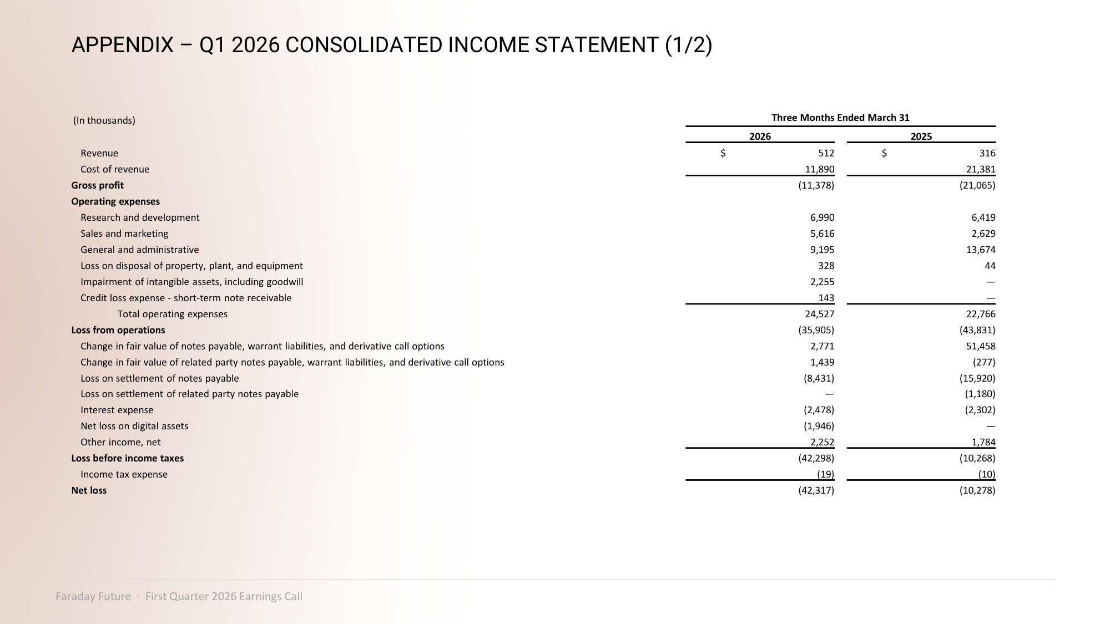
APPENDIX – Q1 2026 CONSOLIDATED INCOME STATEMENT (1/2) Three Months Ended March 31 (In thousands) 2025 2026 $ 316 $ 512 Revenue 21,381 11,890 Cost of revenue (21,065) (11,378) Gross profit Operating expenses 6,419 6,990 Research and development 2,629 5,616 Sales and marketing 13,674 9,195 General and administrative 44 328 Loss on disposal of property, plant, and equipment — 2,255 Impairment of intangible assets, including goodwill — 143 Credit loss expense - short - term note receivable 22,766 24,527 Total operating expenses (43,831) (35,905) Loss from operations 51,458 2,771 Change in fair value of notes payable, warrant liabilities, and derivative call options (277) 1,439 Change in fair value of related party notes payable, warrant liabilities, and derivative call options (15,920) (8,431) Loss on settlement of notes payable (1,180) — Loss on settlement of related party notes payable (2,302) (2,478) Interest expense — (1,946) Net loss on digital assets 1,784 2,252 Other income, net (10,268) (42,298) Loss before income taxes (10) (19) Income tax expense (10,278) (42,317) Net loss Faraday Future · First Quarter 2026 Earnings Call

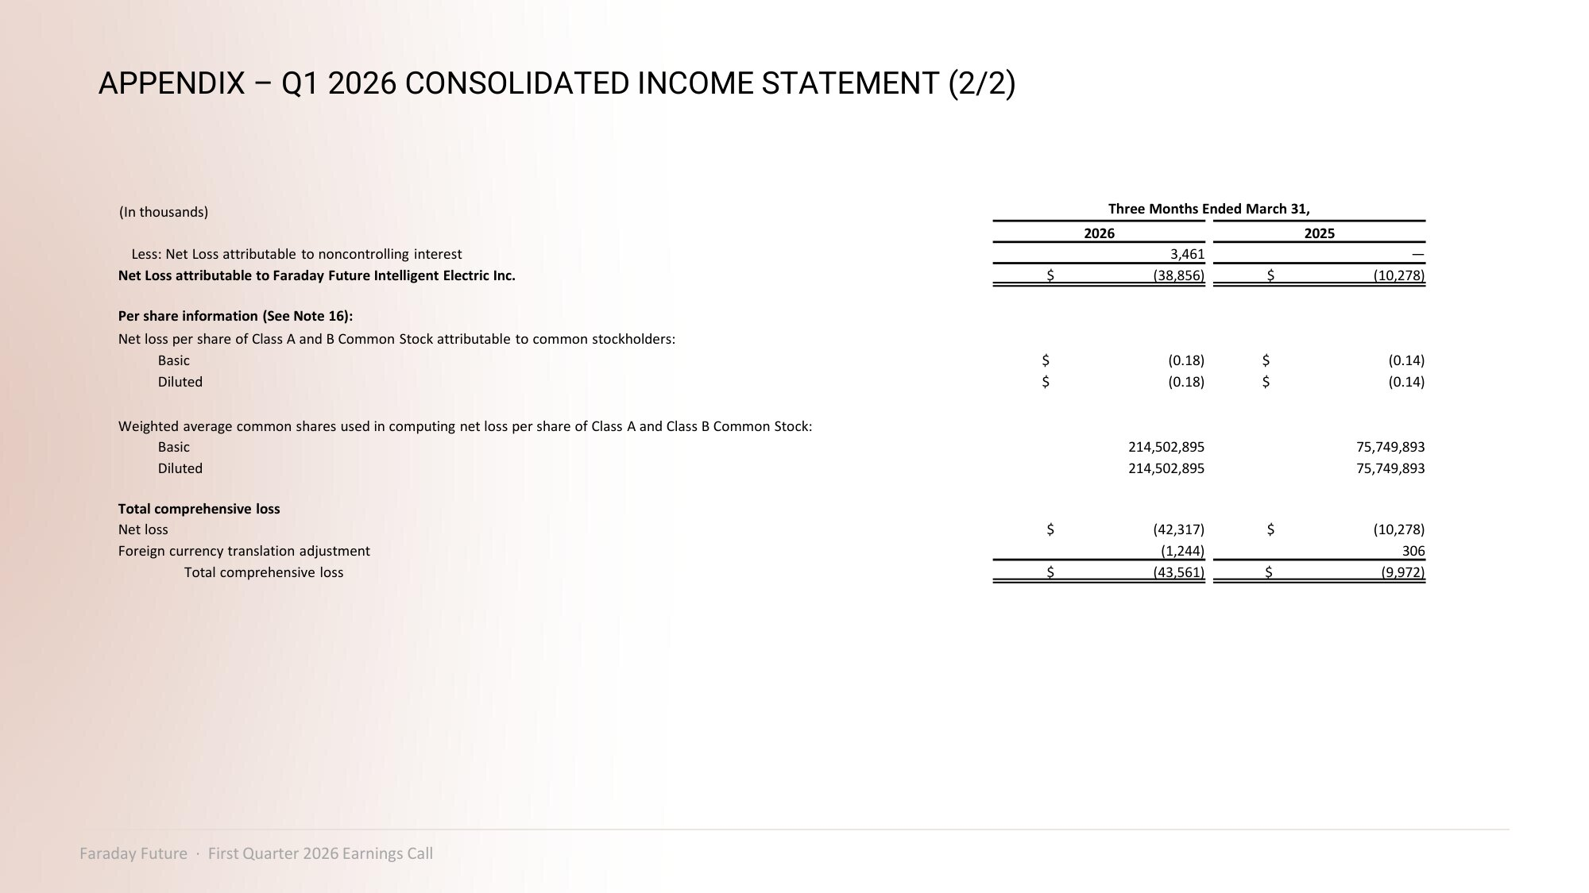
APPENDIX – Q1 2026 CONSOLIDATED INCOME STATEMENT (2/2) Three Months Ended March 31, (In thousands) 2025 2026 — 3,461 Less: Net Loss attributable to noncontrolling interest $ (10,278) $ (38,856) Net Loss attributable to Faraday Future Intelligent Electric Inc. Per share information (See Note 16): Net loss per share of Class A and B Common Stock attributable to common stockholders: $ (0.14) $ (0.18) Basic $ (0.14) $ (0.18) Diluted Weighted average common shares used in computing net loss per share of Class A and Class B Common Stock: 75,749,893 214,502,895 Basic 75,749,893 214,502,895 Diluted Total comprehensive loss $ (10,278) $ (42,317) Net loss 306 (1,244) Foreign currency translation adjustment $ (9,972) $ (43,561) Total comprehensive loss Faraday Future · First Quarter 2026 Earnings Call

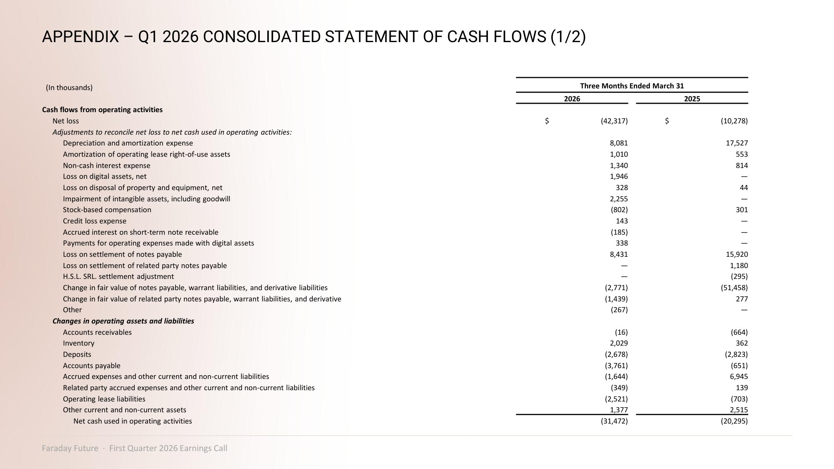
APPENDIX – Q1 2026 CONSOLIDATED STATEMENT OF CASH FLOWS (1/2) Three Months Ended March 31 (In thousands) 2025 2026 Cash flows from operating activities $ (10,278) $ (42,317) Net loss Adjustments to reconcile net loss to net cash used in operating activities: 17,527 8,081 Depreciation and amortization expense 553 1,010 Amortization of operating lease right - of - use assets 814 1,340 Non - cash interest expense — 1,946 Loss on digital assets, net 44 328 Loss on disposal of property and equipment, net — 2,255 Impairment of intangible assets, including goodwill 301 (802) Stock - based compensation — 143 Credit loss expense — (185) Accrued interest on short - term note receivable — 338 Payments for operating expenses made with digital assets 15,920 8,431 Loss on settlement of notes payable 1,180 — Loss on settlement of related party notes payable (295) — H.S.L. SRL. settlement adjustment (51,458) (2,771) Change in fair value of notes payable, warrant liabilities, and derivative liabilities 277 (1,439) Change in fair value of related party notes payable, warrant liabilities, and derivative — (267) Other Changes in operating assets and liabilities (664) (16) Accounts receivables 362 2,029 Inventory (2,823) (2,678) Deposits (651) (3,761) Accounts payable 6,945 (1,644) Accrued expenses and other current and non - current liabilities 139 (349) Related party accrued expenses and other current and non - current liabilities (703) (2,521) Operating lease liabilities 2,515 1,377 Other current and non - current assets (20,295) (31,472) Net cash used in operating activities Faraday Future · First Quarter 2026 Earnings Call

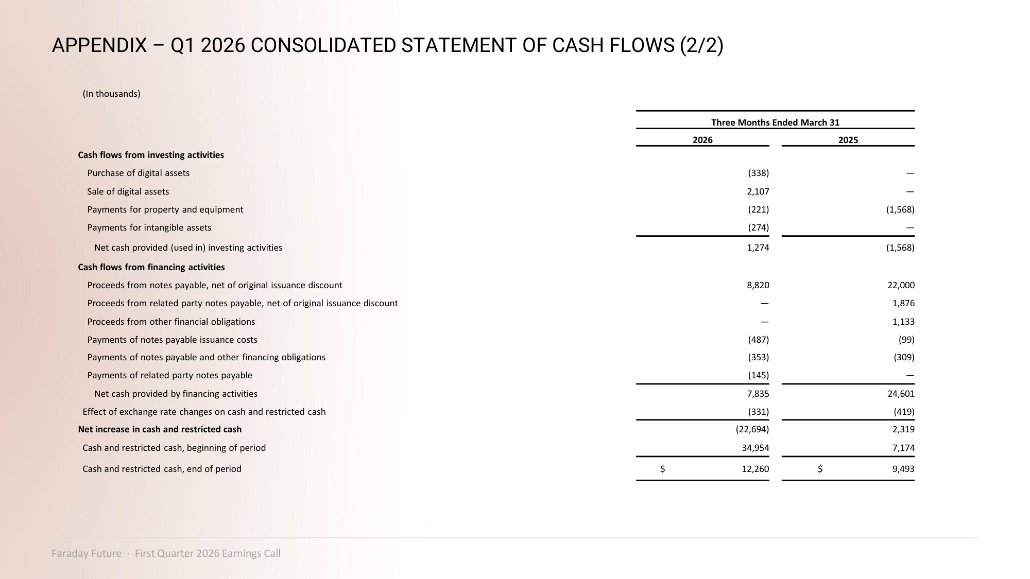
APPENDIX – Q1 2026 CONSOLIDATED STATEMENT OF CASH FLOWS (2/2) (In thousands) Three Months Ended March 31 2025 2026 Cash flows from investing activities — (338) Purchase of digital assets — 2,107 Sale of digital assets (1,568) (221) Payments for property and equipment — (274) Payments for intangible assets (1,568) 1,274 Net cash provided (used in) investing activities Cash flows from financing activities 22,000 8,820 Proceeds from notes payable, net of original issuance discount 1,876 — Proceeds from related party notes payable, net of original issuance discount 1,133 — Proceeds from other financial obligations (99) (487) Payments of notes payable issuance costs (309) (353) Payments of notes payable and other financing obligations — (145) Payments of related party notes payable 24,601 7,835 Net cash provided by financing activities (419) (331) Effect of exchange rate changes on cash and restricted cash 2,319 (22,694) Net increase in cash and restricted cash 7,174 34,954 Cash and restricted cash, beginning of period $ 9,493 $ 12,260 Cash and restricted cash, end of period Faraday Future · First Quarter 2026 Earnings Call

